Friday 3rd of November

Message from the Deputy Head and Headteacher
Welcome back. I hope you managed to get some family time over the half term. A busy half term ahead with Nativity as well as all the normal goings on. Mrs. O’Brien and Mrs. Hermon undertook a review of Maths through the school this week. This is helping us see how the implemnation of ‘Maths Mastery’ is going as well as our new ways of delivering it. We had a good Teacher Development Day just before half term with all the other schools in the Trust. As the Trust stands on the cusp of becoming bigger it was a great opportunity for all the Primary schools to meet one another.
A big big thank you and well done to all the Footbllers and Mr. McCaldon. The final games are tonight (Thursday). They have done us proud and we so appreciate all the support that a lot of you have provided, especially from Mrs. James!
Today I am giving out the standard pro-forma notes that will go out when a child is missing a piece of uniform or PE kit. As I said earlier in the year this is something we want to be really sharp about this year. Thank you for your cooperation in advance.
Hope you have a great Bonfire weekend – be safe.
Feedback
Good to see some of the Winter Class parents this morning at the coffee morning. Feedback on uniform was helpful. We’re aware of some of the quality issues and Mrs. Thomas and me will be monitoring this. We’re also looking at where other schools who have particularly high quality clothing, source theirs. Girls can where grey ankle socks in the summer.
On my ‘radar’ is a large ‘blip’ entitled ‘size of girl’s hair bows’………..more to follow.
We will look at doing the Stay and Play sessions on different days (not just Wednesdays) to allow parents with different working patterns to come along.
Christmas Shoe Boxes. Firstly we will look at ways of reducing the cost next year. Secondly, I have picked up that some parents are uneasy about the leaflet, which is put in which gives a strong Christian message to the recipient. I understand any concern about things like this being too forceful. However we are a Christian school and we have been doing this nigh on 15 years as have a number of local schools both Christian and non Christian. I feel the important thing is that children in need in desperate parts of the world receive the contents: I should think that is all they are focussed on and are just grateful for that. No one has to participate in this and we are very grateful to any that do.
In Mr Burr’s Good Learning Book are:
Winter Class – Star of the week goes to Isla for her effort with her fine motor skills and Tyler for being kind to others. Well done to Elliott for his fantastic effort and positive attitude in Maths.

Spring Class – Archie, Lexie and Arwen for achieving their Red handwriting award. Esmee,Imogen, Isaac, Felix and Nieve for achieving their Amber handwriting award.

Summer Class – Logan Bittner, Isobel and Freya for their Amber handwriting award and to William and Darcy for passing their 99 club.

Autumn Class – William Cottle and Monty Joyce for showing resilience and determination when solving a tricky maths problem.
And a Special mention to:
All of the football team for all their hard work and performances during the small schools football competition.
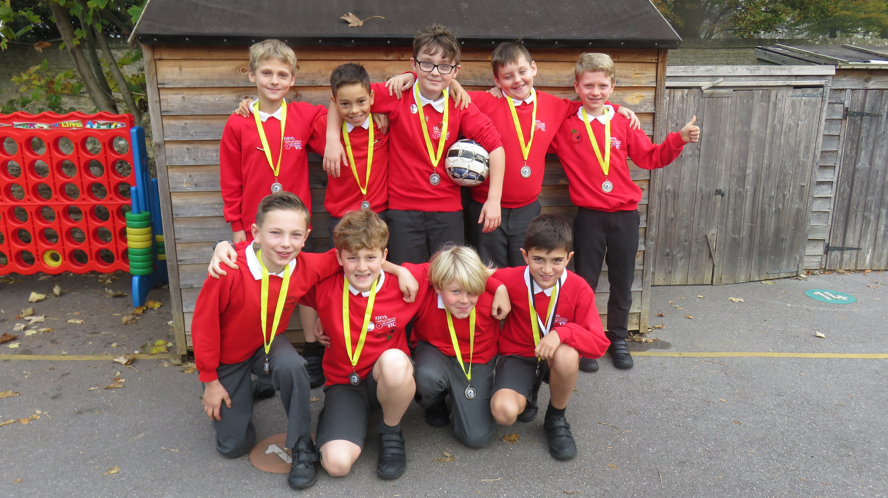

FOKS
School Disco
This year's Winter Disco will be held on Wednesday 6th December in the school. It's going to be at the earlier time of 4.30pm - 6pm so that staff are on hand to help out. Parents of children who do Camp Games will be able to collect at 4.15pm as usual, stay and get children changed in school ready for the 4.30pm start.

There will be all the usual activities to entertain the children, including festive craft, face painting, hot dogs, tuck shop, some great music and hopefully a surprise visitor! More information to follow prior to the event.

Many thanks, FOKS Committee

Dates
November
9th Nov – Autumn Class Sharing Worship
15th Nov – 8.45am Stay and Play

December
4th and 5th Dec – Bikeability
12th Dec – 1.30pm Nativity Play (Winter and Spring)
13th Dec – 6pm Nativity Play (Winter and Spring)
14th Dec – 6pm – Summer Class Concert
20th Dec – 1.30pm Christmas Service
21st Dec – 3rd January – Christmas Break

January

4th January – First day of term
17th January – Stay and Play

