Year 1
Number – addition and subtraction Number – multiplication and division
represent and use number bonds up to 20  Adding 1 Doubles of numbers to 5 Adding 2  Start with number bonds to 10 then build. Use a wide range of objects (including fingers!) and images to model the bonds, e.g. interlocking cubes.  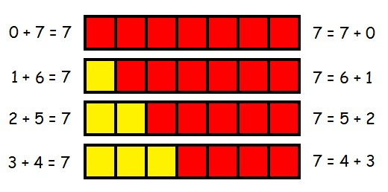  Adding 10 to a number  Adding 0 to a number  Near double  The ones without a family 5+3, 3+5, 6+3, 3+6  add one-digit and two-digit numbers to 20, including zero  Bead strings or bead bars can be used to illustrate addition including bridging ten by counting on 2 then 3.  8 + 5  On a prepared number line… 7 + 4 = 11  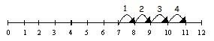  On a hundred square… 3 + 4  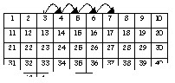 | represent and use number bond facts related subtraction up to 20  Start with number bonds to 10 then build. Use a wide range of objects (including fingers!) and images to model the bonds, e.g. interlocking cubes.  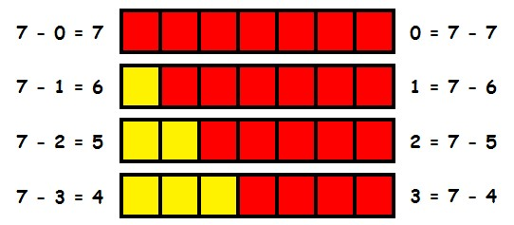 | count in multiples of twos, fives and tens (from number and place value)  Counting using a variety of practical resources  Counting in 2s e.g. counting socks, shoes, animals in the ark… Counting in 10s e.g. hundred square, towers of cubes…  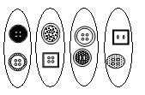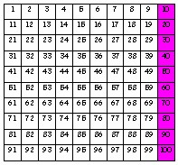  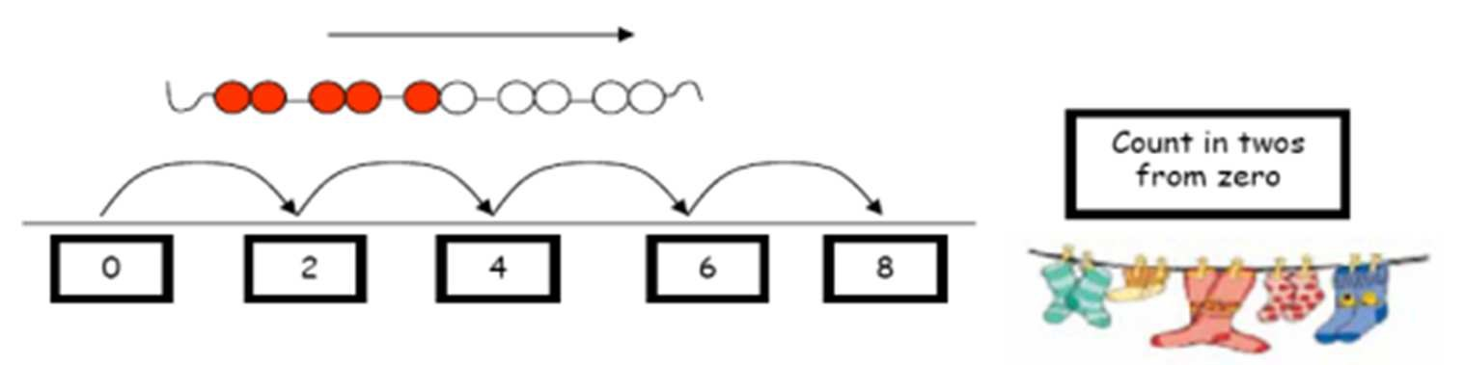  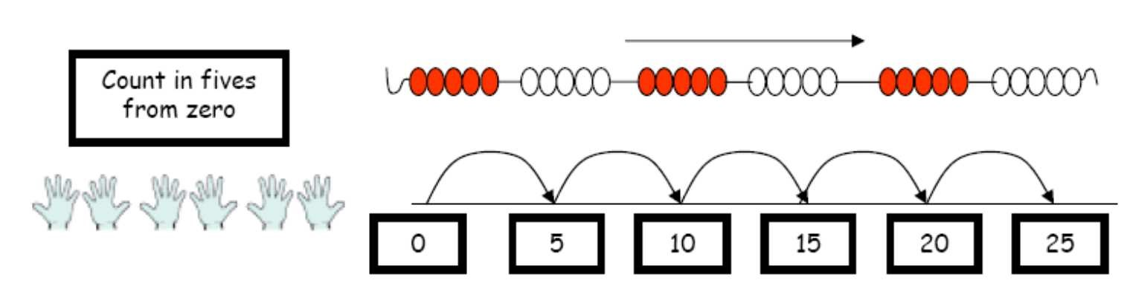  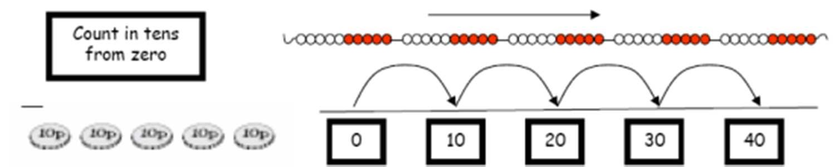  Use rhymes, songs and stories involving counting on and counting back in ones, twos, fives and tens.  Use 2p, 5p and 10p coins. | group and share small quantities  Practical activities involving sharing,  Distributing cards when playing a game, putting objects onto plates, into cups, hoops etc.  Grouping  Sorting objects into 2s / 3s/ 4s etc  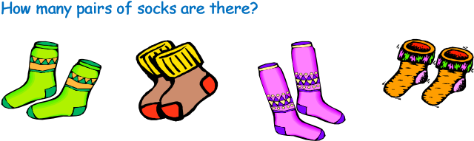  There are 12 crocus bulbs. Plant 3 in each pot. How many pots are there? Jo has 12 Lego wheels. How many cars can she make?  Sharing pictures /objects  12 children get into teams of 4 to play a game. How many teams are there?  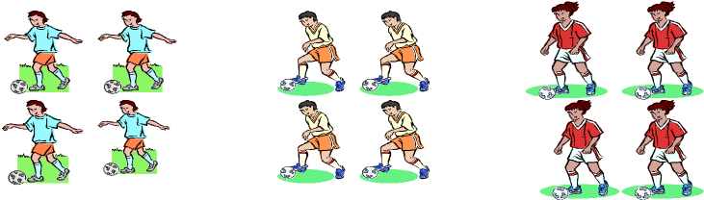  Sweets are shared between 2 people. How many do they have each?
subtract one-digit and two-digit numbers to 20, including zero

Practically with objects, fingers etc.
5 - 2 “Put 5 in your head, 4, 3.”

Taking away
Number lines (numbered and unnumbered, prepared and child constructed)

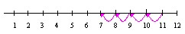
Hundred Square
17 - 3
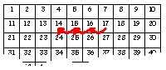
Finding the difference
Number lines (numbered and unnumbered, prepared and child constructed)

+ 6
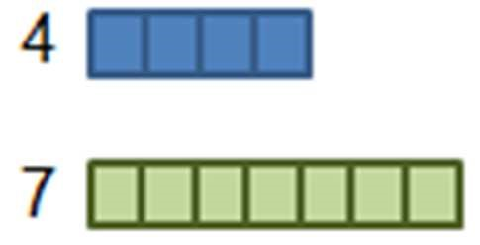

Use practical equipment (such as numicon or cuisenaire) to identify the
‘difference’:

0

1

2

3

4

5

6

7

8

9

10

11

12

‘The difference between 7 and 4 is 3’ or ‘Seven is 3 more than four’.
 |  | double numbers and quantities  Practically double a group of objects and/or quantities to find double of a number by combining then counting the two groups.  Progress onto using known facts and counting (in 1s, 2s, 5s and 10s) to double more efficiently.  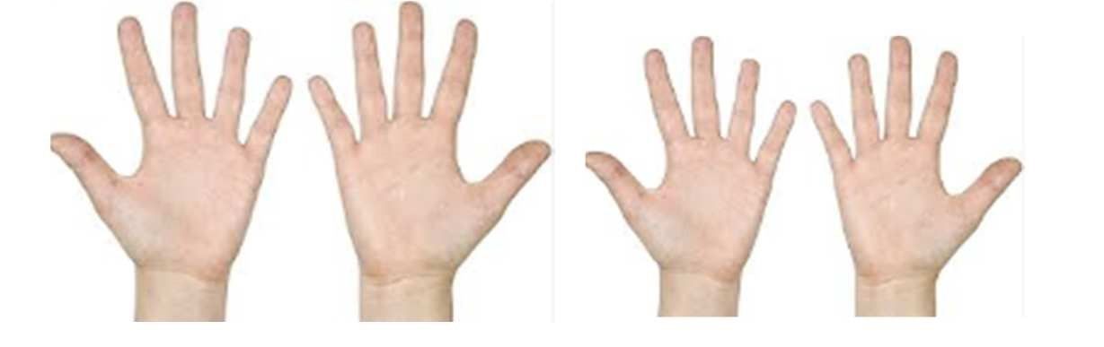  10  and 10  is 20 | half numbers and quantities  Practically halve objects and/or qualities by sharing them out into two piles and then counting the number of objects in each pile, or cutting/folding pictures of objects in half.  Progress onto using known facts and counting (in 1s, 2s, 5s and 10s) to halve more efficiently.  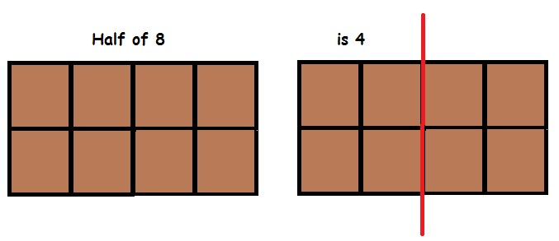

Year 1
Number – addition and subtraction Number – multiplication and division
read, write and interpret mathematical statements involving addition (+) and equals (=) signs  It is important to that children have a clear understanding of the concept of equality, before using the ‘=’ sign. Calculations should be on either side of the ‘=’ to that children don’t misunderstand ‘=’ as to mean ‘the answer’.  15 + 2 = 17  15 = 3 + 12 | read, write and interpret mathematical statements involving and subtraction (–) equals (=) signs  It is important to that children have a clear understanding of the concept of equality, before using the ‘=’ sign. Calculations should be on either side of the ‘=’ to that children don’t misunderstand ‘=’ as to mean ‘the answer’.  15 - 2 = 13 15 = 18 - 3 | make connections between arrays and number patterns  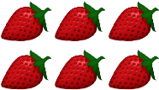  Arrays  Looking at columns Looking at rows  - + 2 + 2 3 + 3  - groups of 2 2 groups of 3  Arrays and repeated addition  - x 2 or 4 + 4  2 x 4 or 2 + 2 + 2 + 2 | make connections between arrays and number patterns  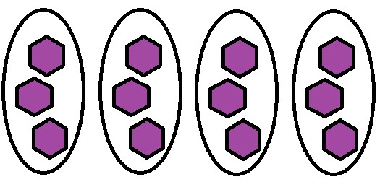  There are 4 groups of 3 in 12.  12 shared between 4 is 3.
solve one-step problems that involve addition and subtraction, using concrete objects and pictorial representations, and missing number problems such as 7 = [] + 4  To support this, when solving calculations, missing numbers should be placed in all possible places:  - + 4 = = 4 + 3 3 + = 7 7 = + 4  - + = 7 7 = 3 +  + ∇ = 7 7 = + ∇  Use all the models and images mentioned above. Discuss which is most effective and why.  Singapore Bar Method  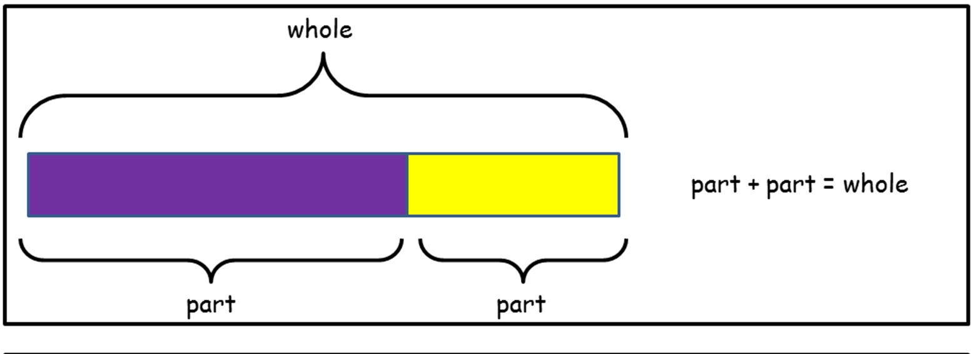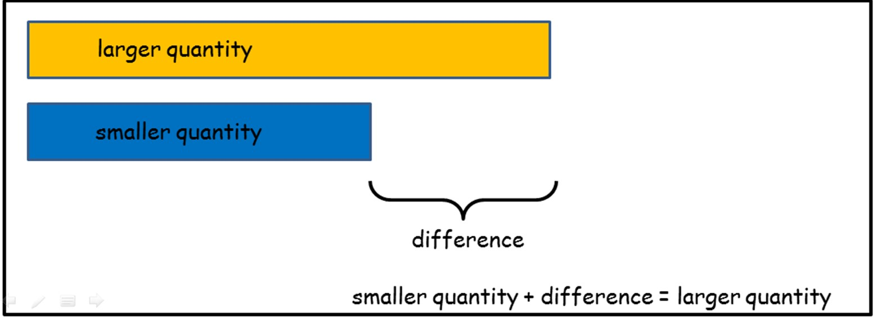 | solve one-step problems that involve addition and subtraction, using concrete objects and pictorial representations, and missing number problems such as 7 = []– 9  To support this, when solving calculations, missing numbers should be placed in all possible places:  16 - 9 = = 16 - 9  16 - = 7 7 = - 9  - 9 = 7 7 = 16 -  - ∇ = 7 7 = - ∇  Use all the models and images mentioned above. Discuss which is most effective and why.  Singapore Bar Method  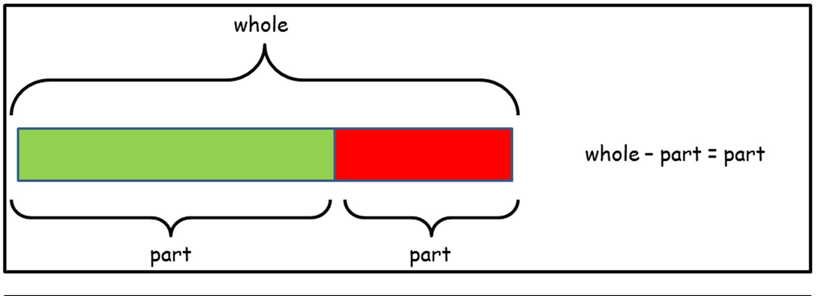  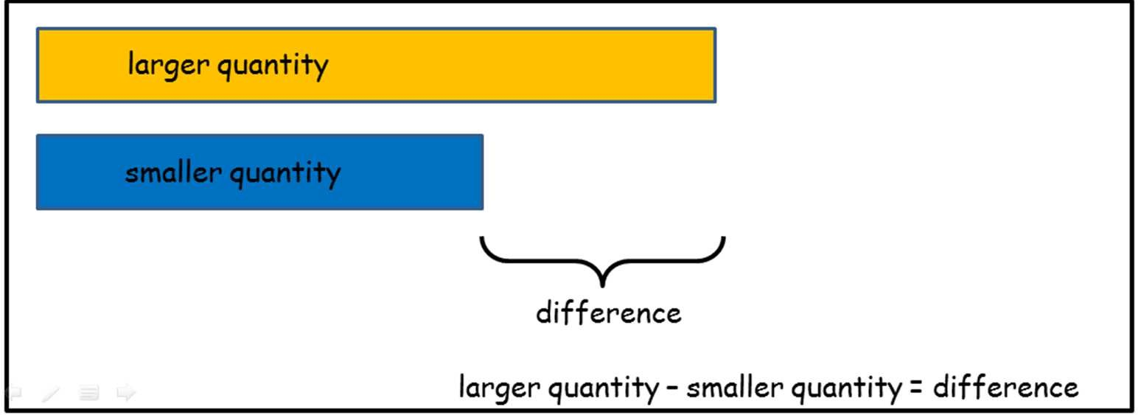 | solve one-step problems involving multiplication, by calculating the answer using concrete objects, pictorial representations and arrays with the support  Use all the models and images mentioned above. Discuss which is most effective and why.  Singapore Bar Method  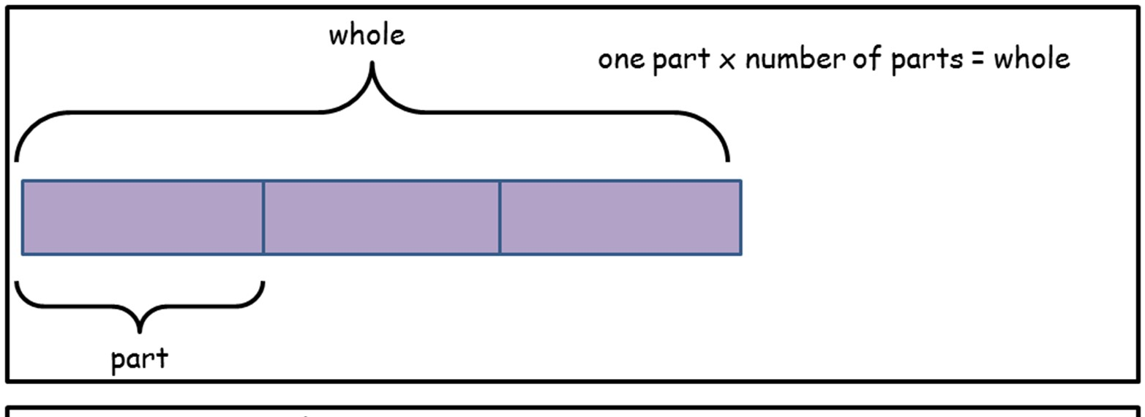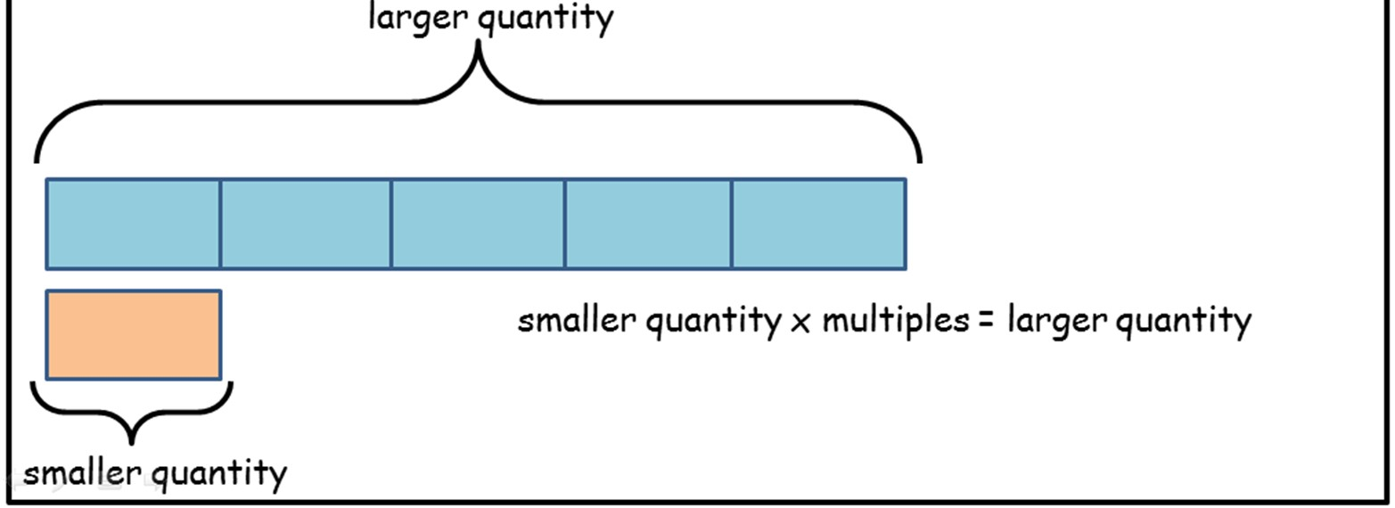 | solve one-step problems involving division, by calculating the answer using concrete objects, pictorial representations and arrays with the support  Use all the models and images mentioned above. Discuss which is most effective and why.  Singapore Bar Method  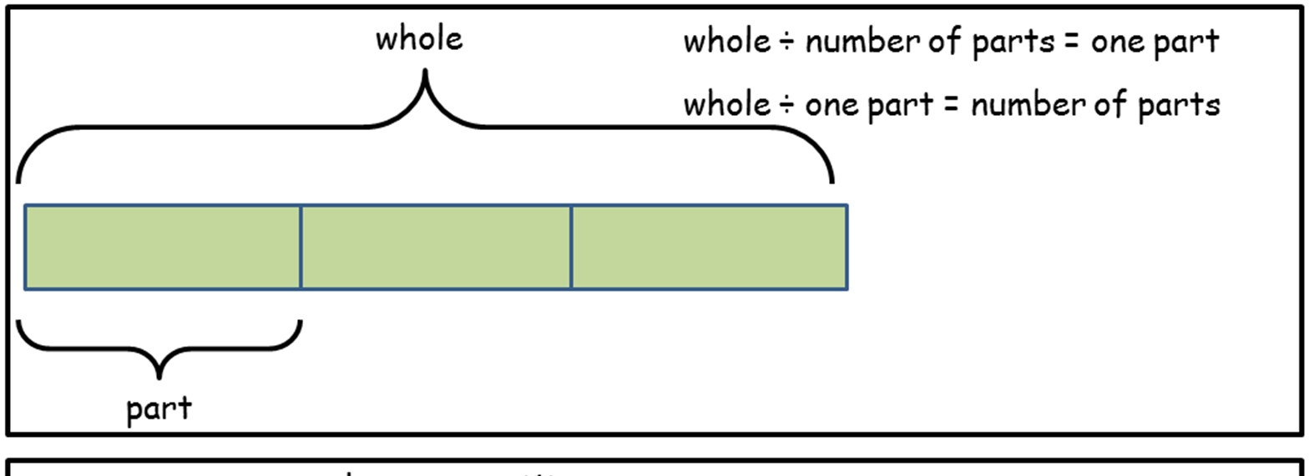  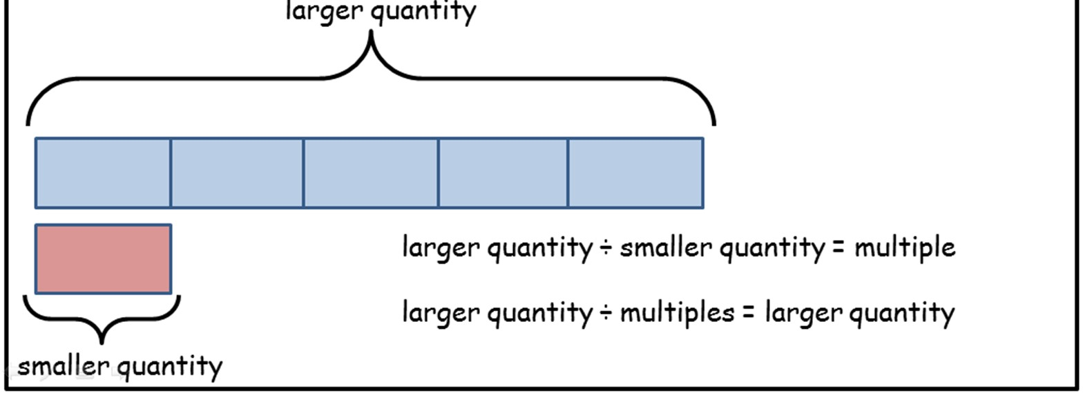
understand and use vocabulary for addition, e.g. put together, add, altogether, total and more than  +, add, more, plus, make, total, altogether, score, double, near double, one more, two more… ten more,  = equals, sign, is the same as  How many more to make…? How many more is… than…? How much more is…?  Repetition of facts with different vocabulary:  “What is 2 add 5?” “What is 2 more than 5?”  “What is 2 plus 5?” What is the total of 2 and 5?” etc | understand and use vocabulary for addition and subtraction, e.g. take away, distance between, difference between and less than  - subtract, take (away), minus, leave, how many are left/left over? how many have gone? one less, two less, ten less… how many fewer is… than…? how much less is…? difference between, half, halve, counting up/back…  = equals, sign, is the same as  Repetition of facts with different vocabulary:  “What is 7 take away 3?” “What is 3 less than 7?”  “What is 7 subtract 3?”  “What is the difference between 3 and 7?” etc | use a variety of language to describe multiplication  count on (from, to), count back (from, to), count in ones, twos, threes, fours,  fives… count in tens, lots of, groups of, x, times, multiply, multiplied by, multiple of, once, twice, three times… ten times… times as (big, long, wide… and so on), repeated addition, array, row, column, double, halve  = equals, sign, is the same as | use a variety of language to describe division  Array, row, column, halve, share, share equally, one each, two each, three each… group in pairs, threes… tens, equal groups of ÷, divide, divided by, divided into, left, left over  = equals, sign, is the same as

