Year 2
Number – addition and subtraction Number – multiplication and division
Doubles of numbers to 10  Near doubles  Bridging  Compensating  recall and use addition and subtraction facts to 20 fluently, and derive and use related facts up to 100  Play games, chant, test etc to increase speed of recalling facts to 20.  Make models and images to display facts.  Investigate related facts to 100 and repeat above. | recall and use addition and subtraction facts to 20 fluently, and derive and use related facts up to 100  Play games, chant, test etc to increase speed of recalling facts to 20. Make models and images to display facts.  Investigate related facts to 100 and repeat above. | recall and use multiplication facts for the 2, 5 and 10 multiplication tables, including recognising odd and even numbers  Play games, chant, test etc to increase speed of recalling facts to 20. Make models and images to display facts.  Investigate related facts to 100 and repeat above. | recall and use division facts for the 2, 5 and 10 multiplication tables, including recognising odd and even numbers  Play games, chant, test etc to increase speed of recalling facts to 20. Make models and images to display facts.  Investigate related facts to 100 and repeat above.
add numbers using concrete objects, pictorial representations, and mentally,  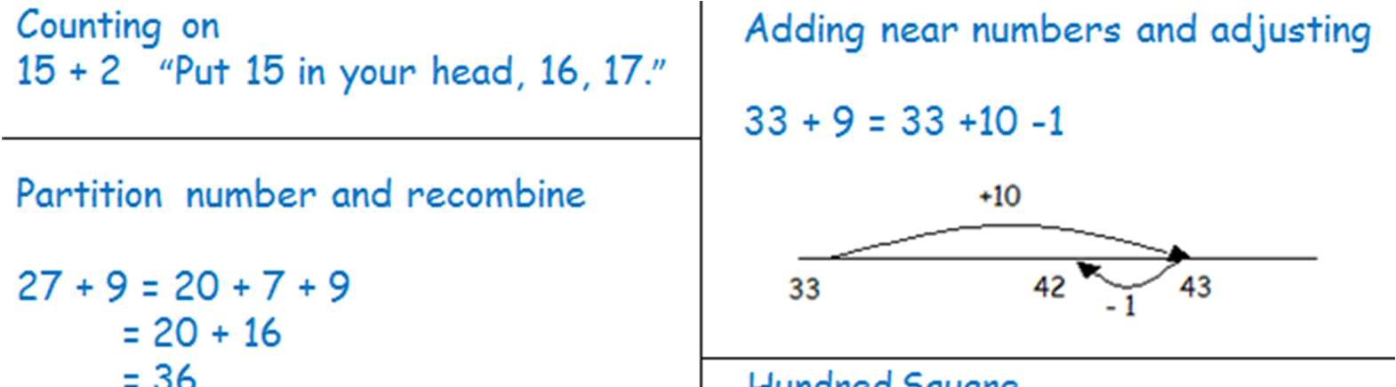  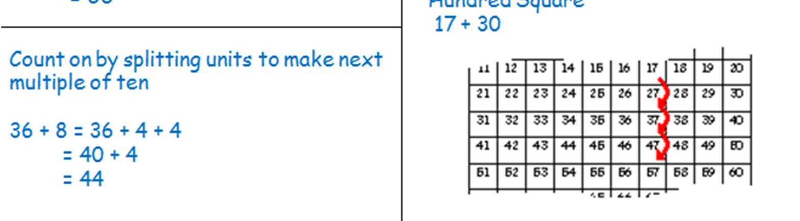  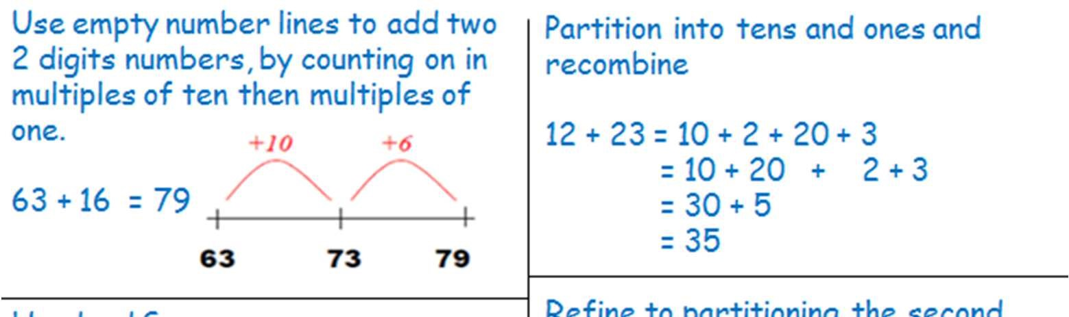  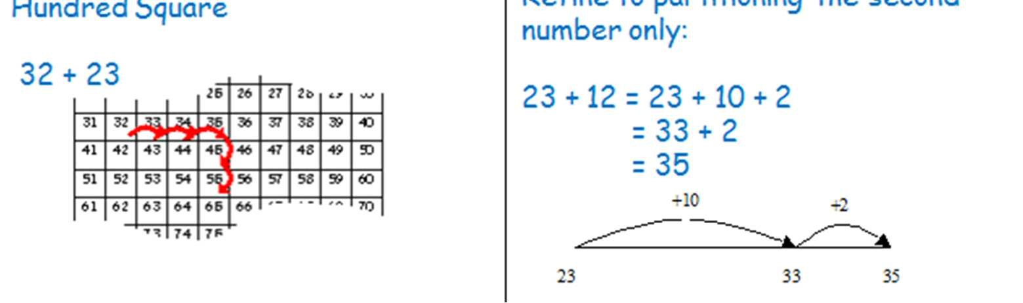  • adding three one-digit numbers  including:  •  a two-digit number and ones or tens  •  two two-digit numbers  Use knowledge of adding, for example number bonds first or largest numbers first.  3 + 9 + 7 = (3 +7) + 9  = 10 + 9 = 19 | subtract numbers using concrete objects, pictorial representations, and mentally, including:  • a two-digit number and ones or tens  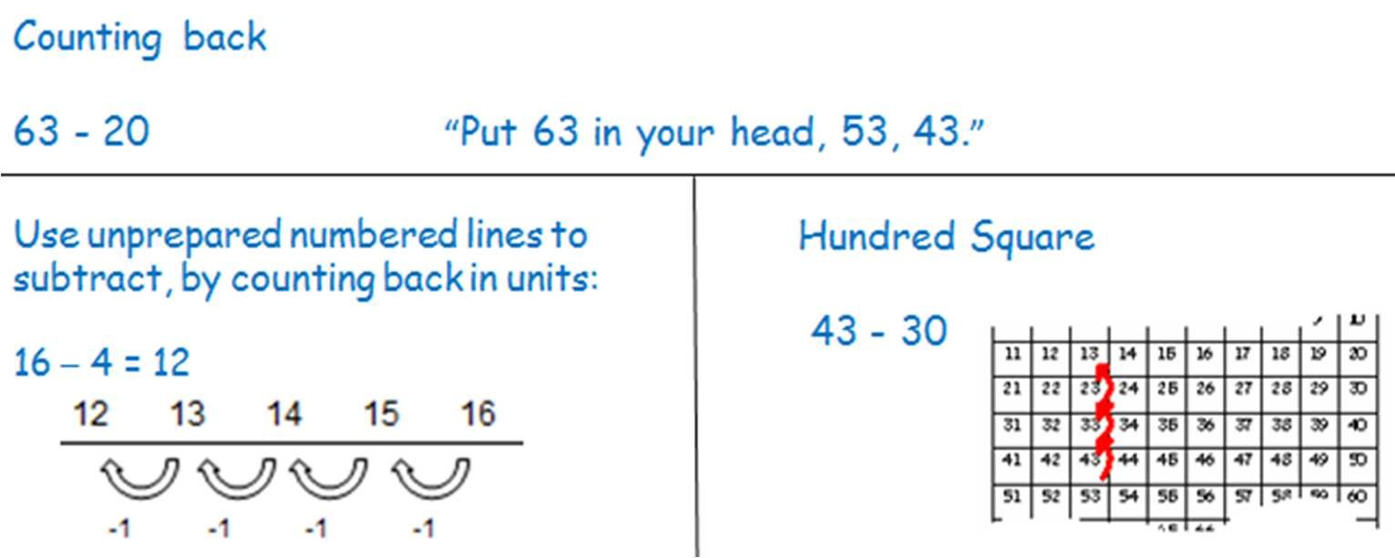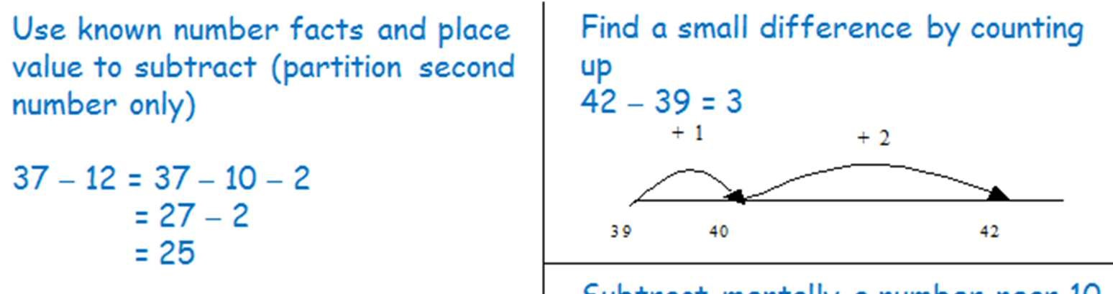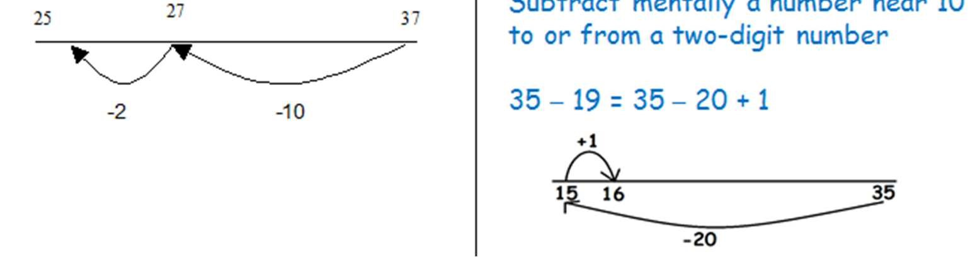  •  two two-digit numbers | connect the 10 multiplication table to place value, and the 5 multiplication table to the divisions on the clock face  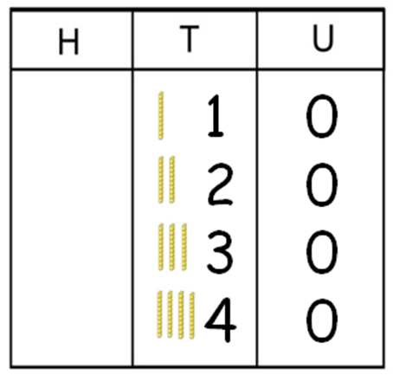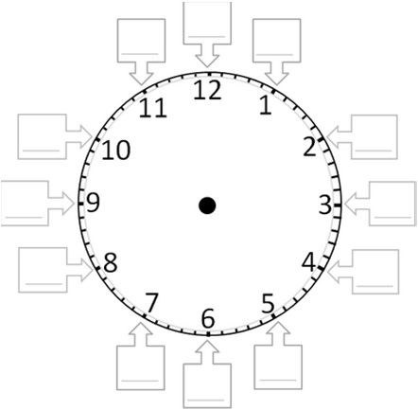 | connect the 10 multiplication table to place value, and the 5 multiplication table to the divisions on the clock face  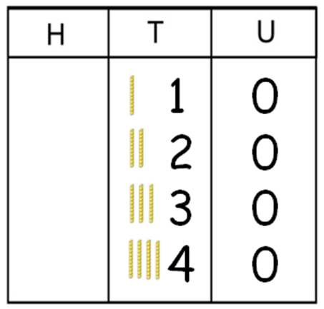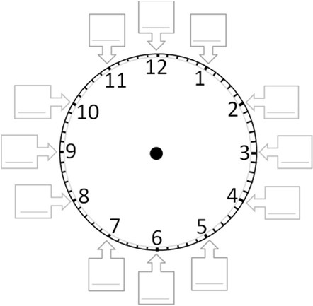
 |  | relate multiplication to arrays and to repeated addition using a range of materials and contexts  Practically combine groups of objects (2s, 5s and 10s) and verbalise (then record) what has been found out: There are 3 plates. Each plate has 2 star biscuits on. How many biscuits are there? 2 add 2 add 2 equals 6  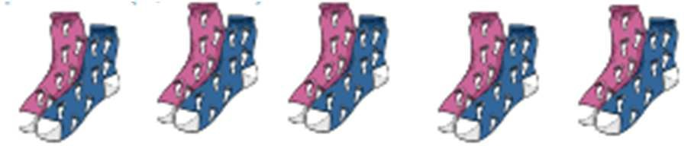  Mum washed 5 pairs of socks, how many socks did she get out of the washing machine? 2 + 2 + 2 + 2 + 2 = 10  Use arrays for repeated addition and relate this to the x calculation: (Use counters or objects as well as visual representations to support understanding)  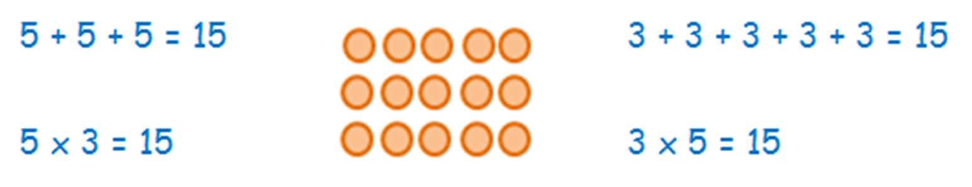  Use a number line for repeated addition:  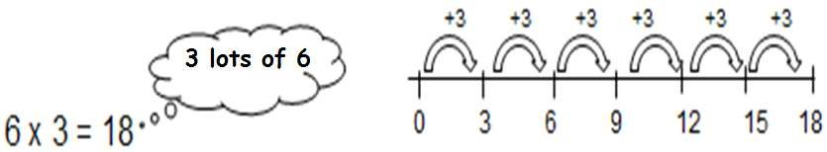 | relate division to grouping and sharing discrete and continuous quantities, to arrays and to repeated subtraction using a range of materials and contexts  Initially, pupils to practically ‘share’ and ‘group’ using practical equipment and pictorial representation. Move on to using arrays to identify groups, use physical counters before pictorial representations:  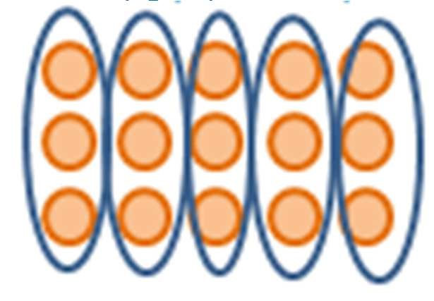  How many groups of 3 are in 15?  Grouping using a number line:  There are 30 children in the class, how many groups of 5 can we get into?  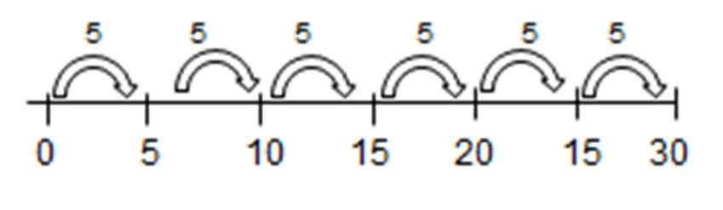  Use counters to support pupils understanding:  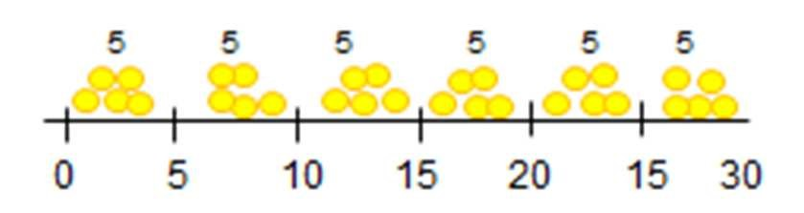
record addition and subtraction in columns  Use partitioned column method.  Solve calculations that do not cross the tens boundary, until they are secure with the method. Then solve calculations that do cross the tens boundary. Use base 10 (diennes) to support the understanding of ‘carrying’ and the value of  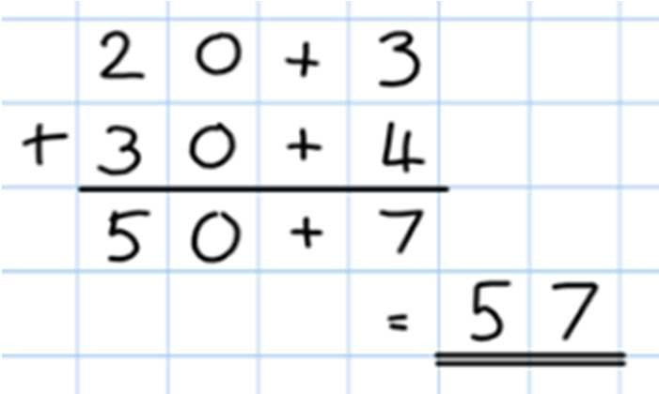  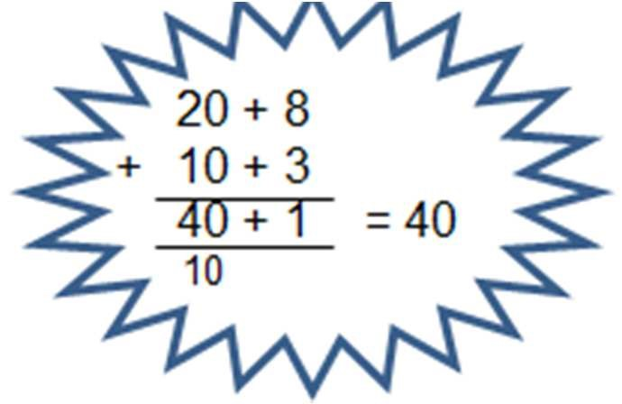  ‘digits’.  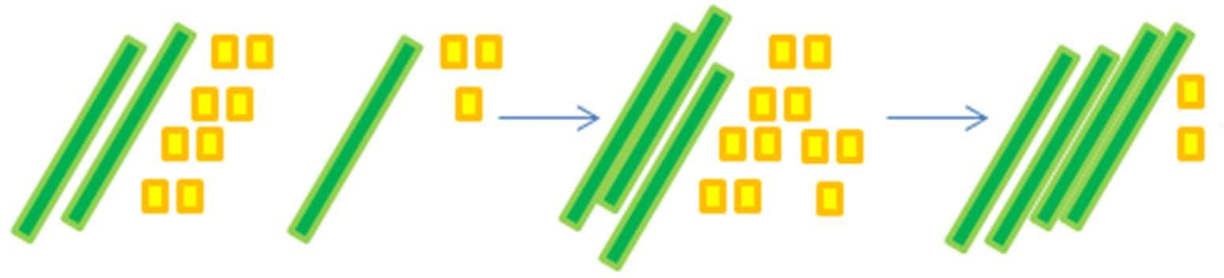  28 + 13 | record subtraction in columns  Introduce partitioned column method where no exchanging is required:  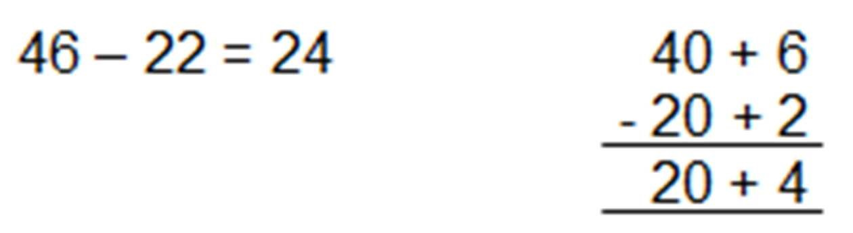  use base 10 (diennes) to support understanding  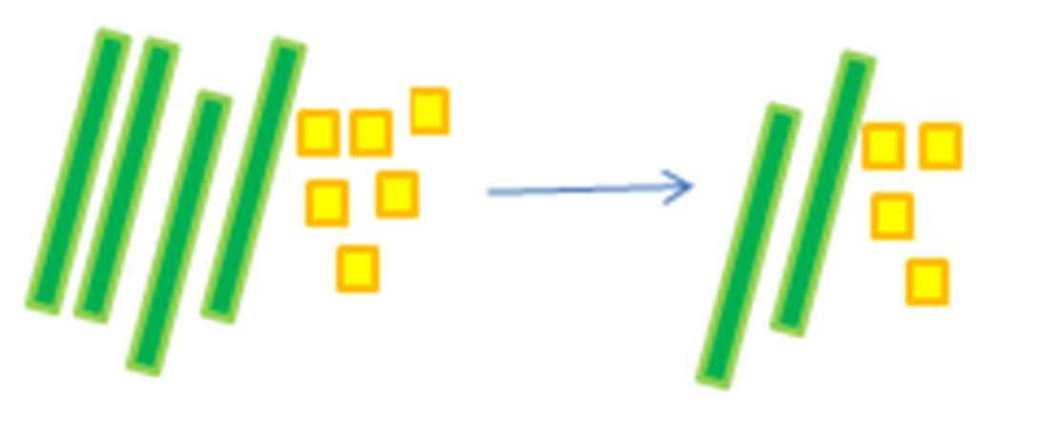 | calculate mathematical statements for multiplication within the multiplication tables and write them using the multiplication (×) and equals (=) signs  3 x 4 = 12  Repetition of sentence with different vocabulary:  “3 times 4 equals 12”  “3 lots of 4 are 12”  “3 multiplied by 4 equals 12”  “The product of 3 and 4 is 12” | calculate mathematical statements for division within the multiplication tables and write them using the division (÷) and equals (=) signs  12 ÷ 4 = 3  Repetition of sentence with different vocabulary:  “12 divided by 4 equals 3”  “12 shared by 4 is 3”  “12 grouped into 4s is 3”

Year 2
Number – addition and subtraction Number – multiplication and division
solve problems with addition:  - using concrete objects and pictorial representations, including those involving numbers, quantities and measures  - applying increasing knowledge of mental and written methods  Use all the models and images mentioned above. Discuss which is most effective and why.  Singapore Bar Method  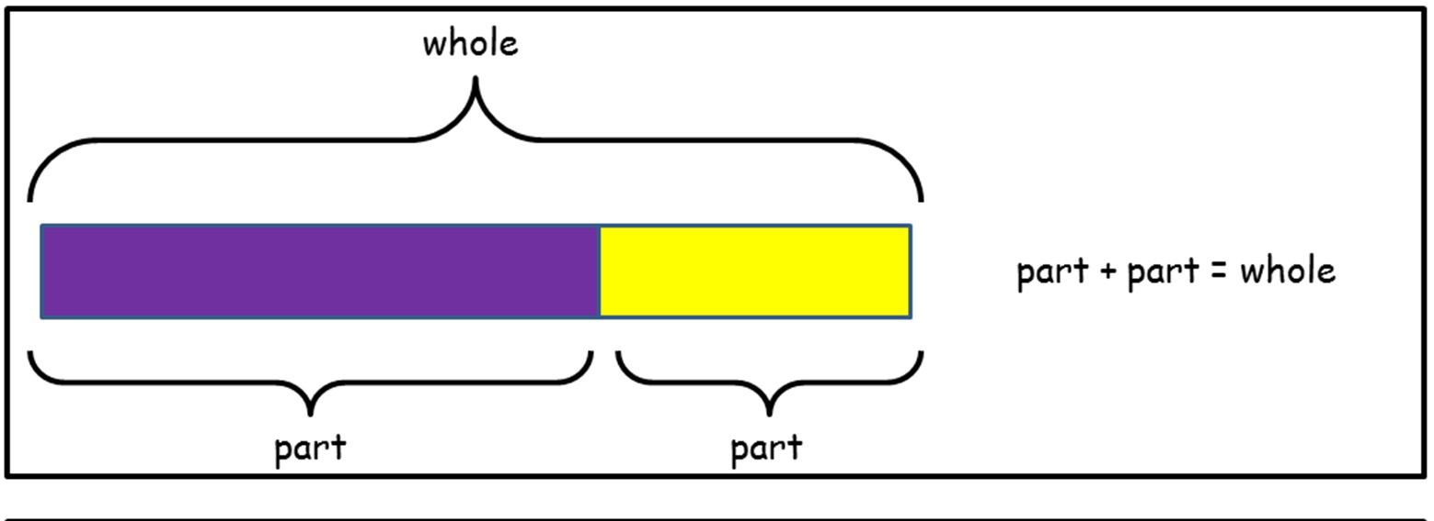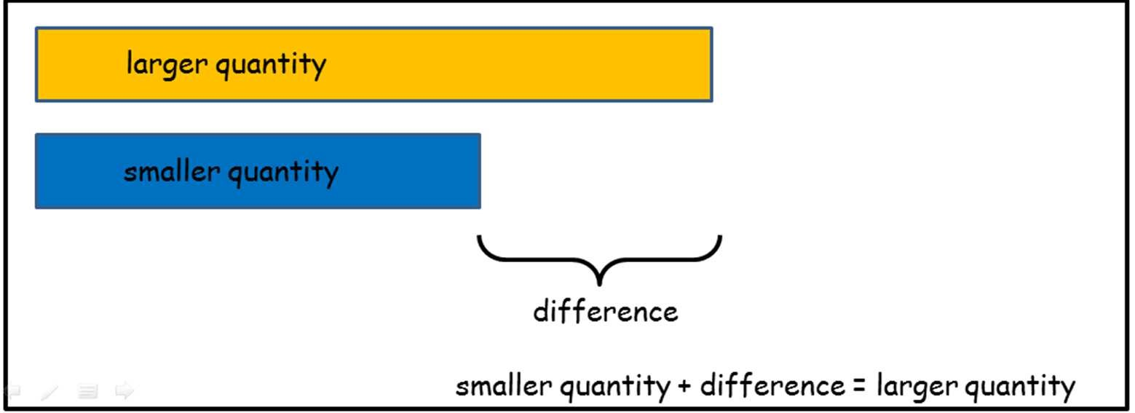 | solve problems with subtraction:  • using concrete objects and pictorial representations, including those involving numbers, quantities and measures applying increasing knowledge of mental and written methods  Use all the models and images mentioned above. Discuss which is most effective and why.  Singapore Bar Method  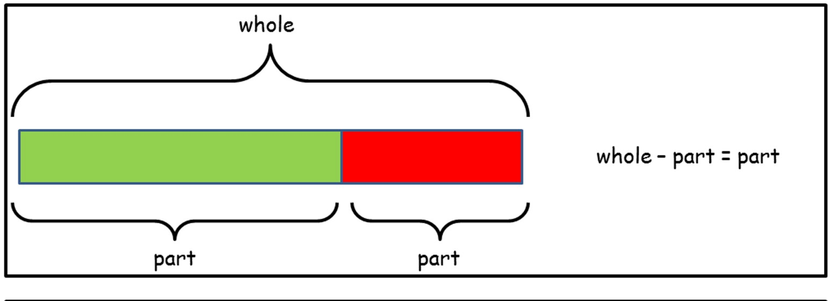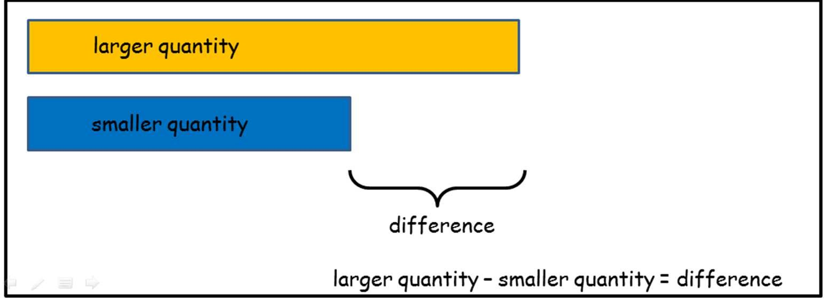 | solve problems involving multiplication, using materials, arrays, repeated addition, mental methods, and multiplication facts, including problems in contexts  Use all the models and images mentioned above. Discuss which is most effective and why.  Singapore Bar Method  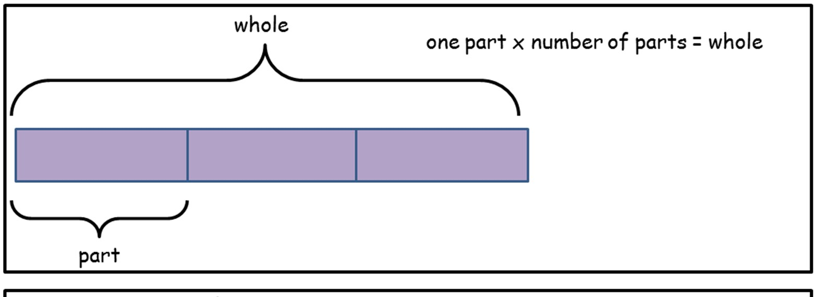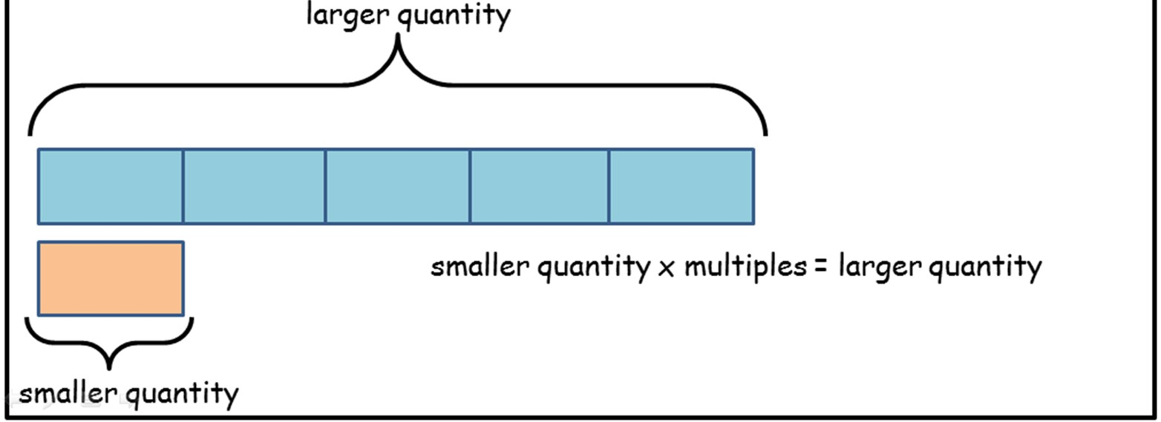 | solve problems involving division, using materials, arrays, repeated addition, mental methods, and division facts, including problems in contexts  Use all the models and images mentioned above. Discuss which is most effective and why.  Singapore Bar Method  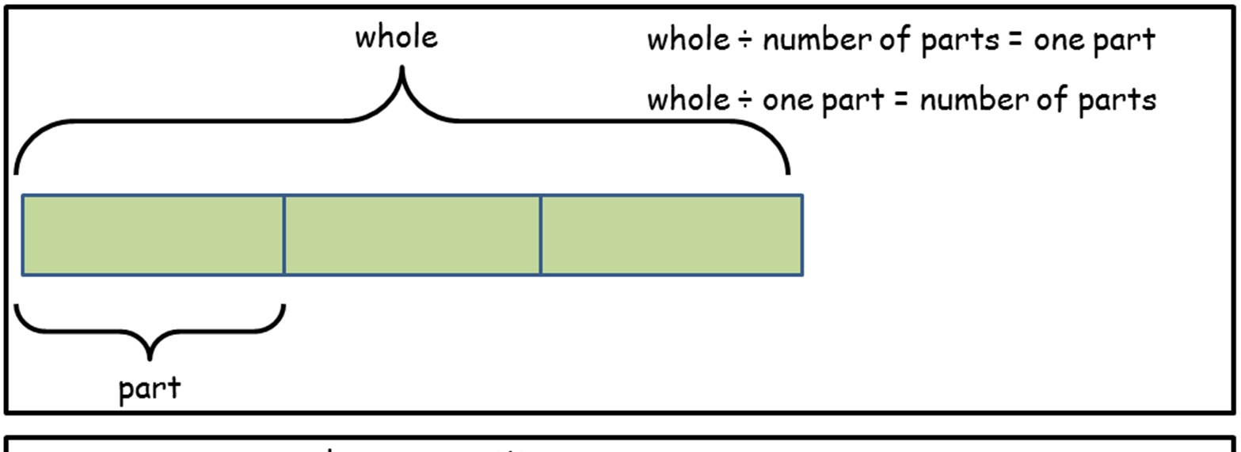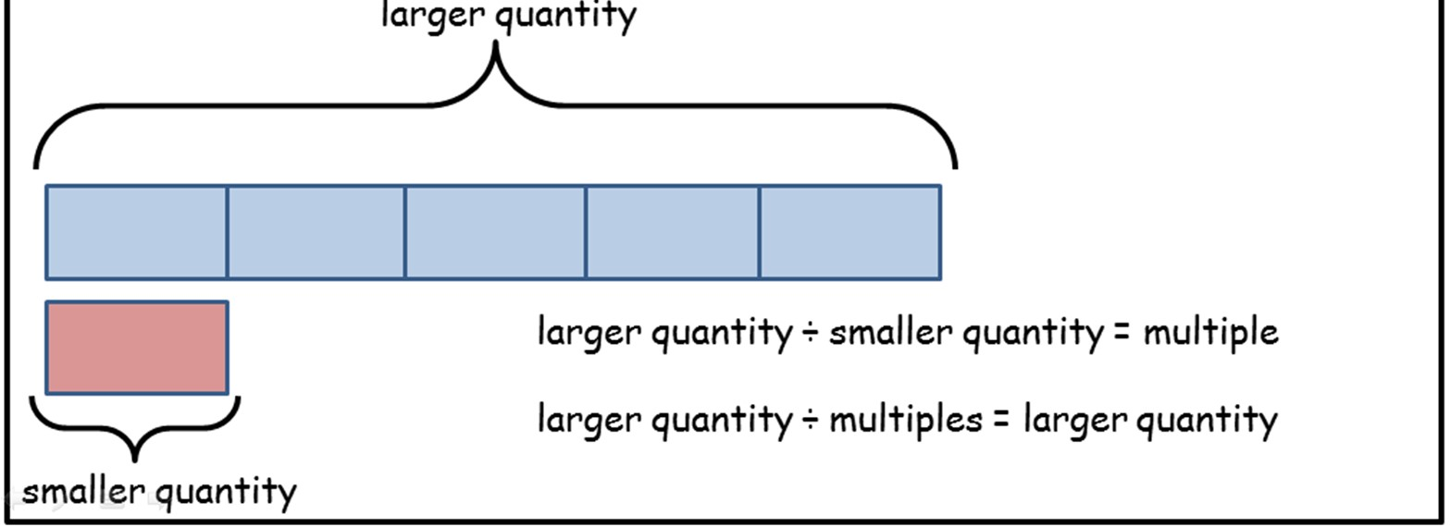
recognise and use the inverse relationship between addition and subtraction and u  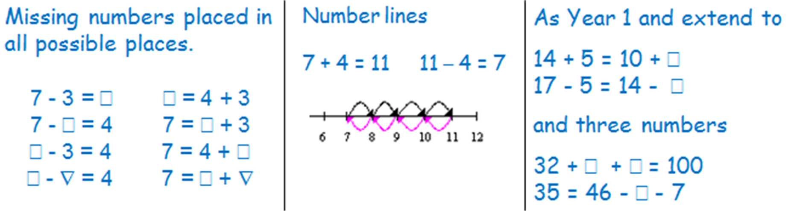 | se this to solve missing number problems | recognise and use the inverse relationship between multiplication and division and  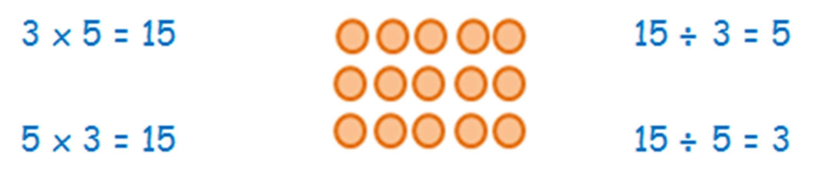 | use this to solve missing number problems
show that addition of two numbers can be done in any order (commutative)  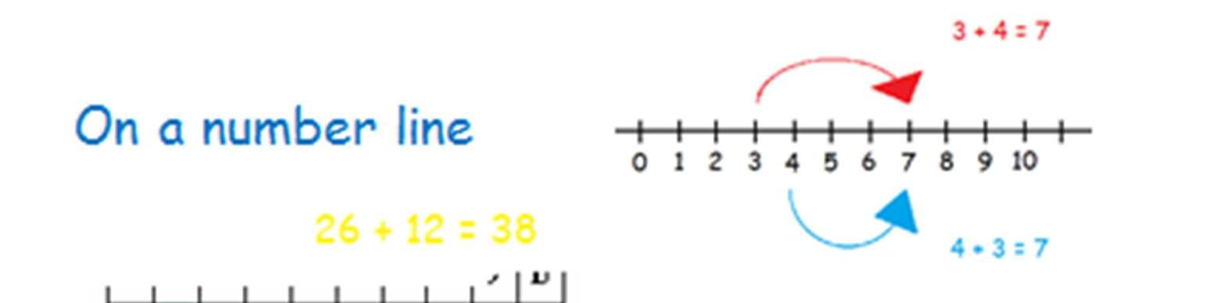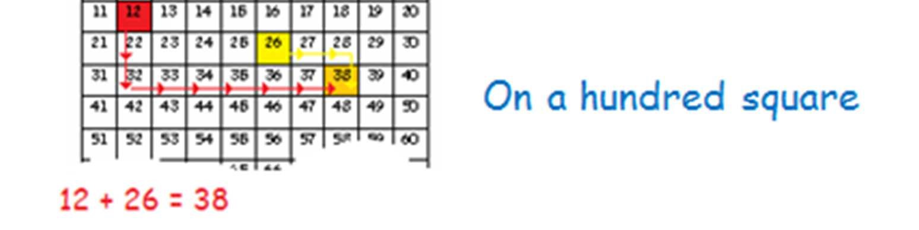 | show that subtraction of two numbers cannot be done in any order  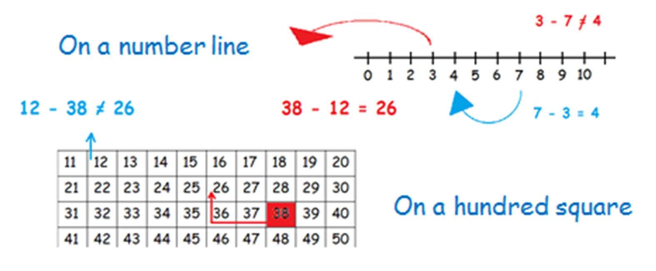 | show that multiplication of two numbers can be done in any order (commutative)  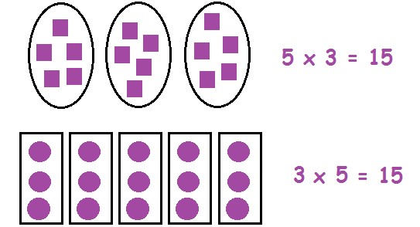 | show that division of one number by another cannot be done in any order  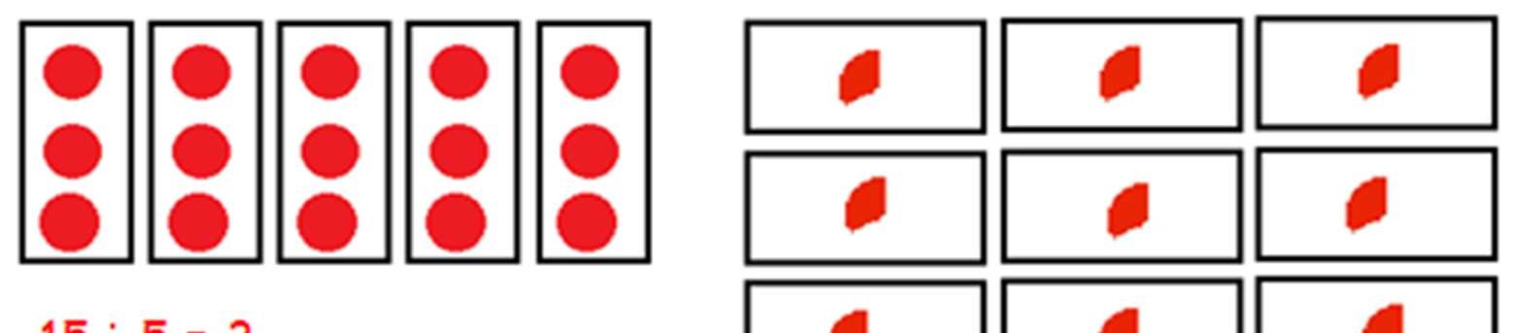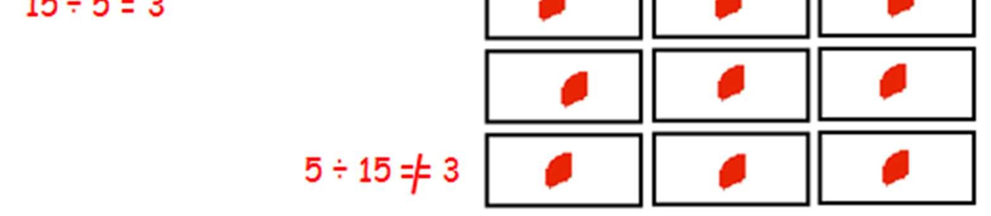
check their calculations, including adding numbers in a different order to check  addition (for example, 5 + 2 + 1 = 1 + 5 + 2 = 1 + 2 + 5) - establishing commutativity and associativity of addition  See models and images above. | check their calculations, including by adding to check subtraction  See models and images above.
recognise and use the inverse relationship between addition and subtraction and use this to check calculations  See models and images above. | recognise and use the inverse relationship between addition and subtraction and use this to check calculations  See models and images above. | use commutativity and inverse relations to develop multiplicative reasoning (for ex  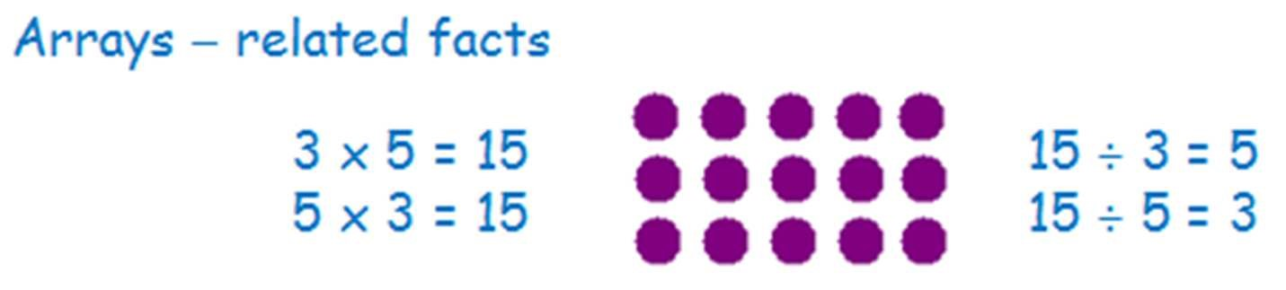 | ample, 4 × 5 = 20 and 20 ÷ 5 = 4)
extend their understanding of the language of addition to include sum  +, add, more, plus, make, sum, total, altogether, score, double, near double, one more, two more… ten more, How many more to make…? How many more is… than…? How much more is…? Repetition of facts with different vocabulary:  “What is 2 add 5?” “What is 2 more than 5?”  “What is 2 plus 5?” What is the total of 2 and 5?” etc  = equals, sign, is the same as | extend their understanding of the language of subtraction to include difference  - subtract, subtraction, take (away), minus, leave, how many are left/left over? one less, two less… ten less… one hundred less, how many fewer is… than…? how much less is…? difference between, half, halve, tens boundary 13 + 5 = 8 Repetition of sentence with different vocabulary:  “13 subtract 5 equals 8” “5 less than 13 is 8  “13 take away 5 equals 8” “The difference between 13 and 5 is 8” etc  = equals, sign, is the same as | use a variety of language to describe multiplication  count on (from, to), count back (from, to), count in ones, twos, threes, fours,  fives… count in tens, lots of, groups of, x, times, multiply, multiplied by, multiple of, once, twice, three times… ten times… times as (big, long, wide… and so on), repeated addition, array, row, column, double, halve  = equals, sign, is the same as | use a variety of language to describe division  Array, row, column, halve, share, share equally, one each, two each, three each… group in pairs, threes… tens, equal groups of, ÷, divide, divided by, divided into, left, left over  = equals, sign, is the same as

