**English**

This term, our writing will be based on the text ‘The Explorers’ by Katherine Rundell.

We will be continuing to look at sentence structure through Spelling Punctuation And Grammar (SPAG) lessons this term, continuing to work on our understanding and application of word classes and using clauses and phrases effectively in our writing.



**Keevil CE Aided Primary School**

[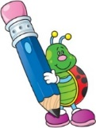](http://www.google.co.uk/url?sa=i&rct=j&q=clipart+writing&source=images&cd=&cad=rja&uact=8&ved=0CAcQjRw&url=http://www.cliparthut.com/writing-folder-clipart.html&ei=dPd2VdDGHILj7Qabg4C4CQ&psig=AFQjCNH0fs5RgKxxjjYWx7Q7pSDbGug4cA&ust=1433946350728263)**Learning in the term ahead**

**Class: Autumn Term: 3**

[](http://www.google.co.uk/url?sa=i&rct=j&q=clipart+geography&source=images&cd=&cad=rja&uact=8&ved=0CAcQjRw&url=http://www.clipartpanda.com/categories/geography-clipart-black-and-white&ei=G_l2Vbr0KILm7ga9g4G4BA&psig=AFQjCNGWbF-50cfXyU3PVpIvmPLoTqpYJA&ust=1433946761437782)[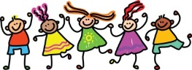](http://www.google.co.uk/url?sa=i&rct=j&q=clipart+friends&source=images&cd=&cad=rja&uact=8&ved=0CAcQjRw&url=http://cliparts.co/clip-art-of-friends&ei=EPp2VbbRMOGs7Ab00oOYBg&psig=AFQjCNEs9KYihyqCQapdwBhANqtbU0KZvQ&ust=1433947009480034)[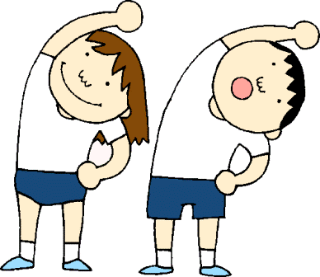](http://www.google.co.uk/url?sa=i&rct=j&q=clipart+pe&source=images&cd=&cad=rja&uact=8&ved=0CAcQjRw&url=http://www.clipartpanda.com/categories/pe-class-clipart&ei=i_l2VdWCNcLB7AbC9YH4CQ&psig=AFQjCNHunG1V_E8HkEKpZlyb39Vtsy2gCA&ust=1433946879166045)[](http://www.google.co.uk/url?sa=i&rct=j&q=clipart+science&source=images&cd=&cad=rja&uact=8&ved=0CAcQjRw&url=http://manshamahtani.com/science-fair-clip-art&ei=TPh2VaP3AoSU7AbDsoCICQ&psig=AFQjCNHoHI3d_L_KUxYR_usObtwTDUPUhQ&ust=1433946549049225)[](http://www.google.co.uk/url?sa=i&rct=j&q=clipart+religion&source=images&cd=&cad=rja&uact=8&ved=0CAcQjRw&url=http://www.canstockphoto.com/religion-icons-5285101.html&ei=wPd2VeivINDT7AaRiYKQBQ&psig=AFQjCNGvETEcdgp3JNG30BR3eRGGsnGDJw&ust=1433946411911815)[](http://www.google.co.uk/url?sa=i&rct=j&q=clipart+computer&source=images&cd=&cad=rja&uact=8&ved=0CAcQjRw&url=http://www.clipartpanda.com/categories/kids-art-class-clip-art&ei=Bvh2Vau4FqTg7QaTgoHQBw&psig=AFQjCNGMIdQ6tV01DJDDgd3KLhh8fcT_JA&ust=1433946483855768)[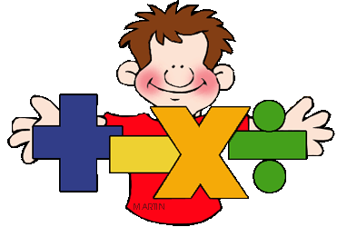](http://www.google.co.uk/url?sa=i&rct=j&q=clipart+maths&source=images&cd=&cad=rja&uact=8&ved=0CAcQjRw&url=http://math.phillipmartin.info/&ei=4_Z2VaiaFciN7AaY9IGwBg&psig=AFQjCNGo5VxK1fCJXBQEo_6NjKx0w56UjQ&ust=1433946187819279)

**History**

In Geography we will be continuing our study of South America but will be focusing our learning on Brazil. Learning about their environmental regions, key physical and human characteristics, similarities and differences in where we live and it’s major cities.

**PSHE**

This term our PSHE day will be based on the theme of Anti-Bullying. We will be reviewing our classroom rules, what is bullying? And what to do if you think you’re being bullied.

**PE**

Acorn PE will be taking our lessons this term. The children will be playing a variety of different sports and working on a range of new and existing skills.

**Science**

This term our topic will be ‘Materials’. We will be looking at comparing and identifying a range of materials based on their properties, solubility, transparency etc. Developing our understanding of solids, liquids and gases. Demonstrate our understanding of reversible states through different experiments; practicing fair tests. Finally, continuing to explain and report our findings during practical activities.

**Computing**

This term we will be focusing on E-Safety and our general ICT skills. Demonstrating how to use technology safely and responsibly as well as learning how to use a range of programmes effectively.

**RE**

We will be studying Sikhism during our RE lessons this term, focusing on the key question: ‘Are Sikh stories important today?’ The children will be looking at various stories and explaining what they teach people about how to behave; how some stories can teach Sikhs about what’s important in life and recognize that religious stories can be an important way of expressing belief and meaning.

**Maths**

This term we will be continuing to work on the four operations; going over methods for addition, subtraction, multiplication and division within a range of contexts. The children will also be developing their understanding of fractions and decimals – converting fractions and decimals, ordering and comparing mixed and improper fractions, identifying and simplifying fractions as well as using all four operations to solve problems related to fractions.