Negative Numbers Revision
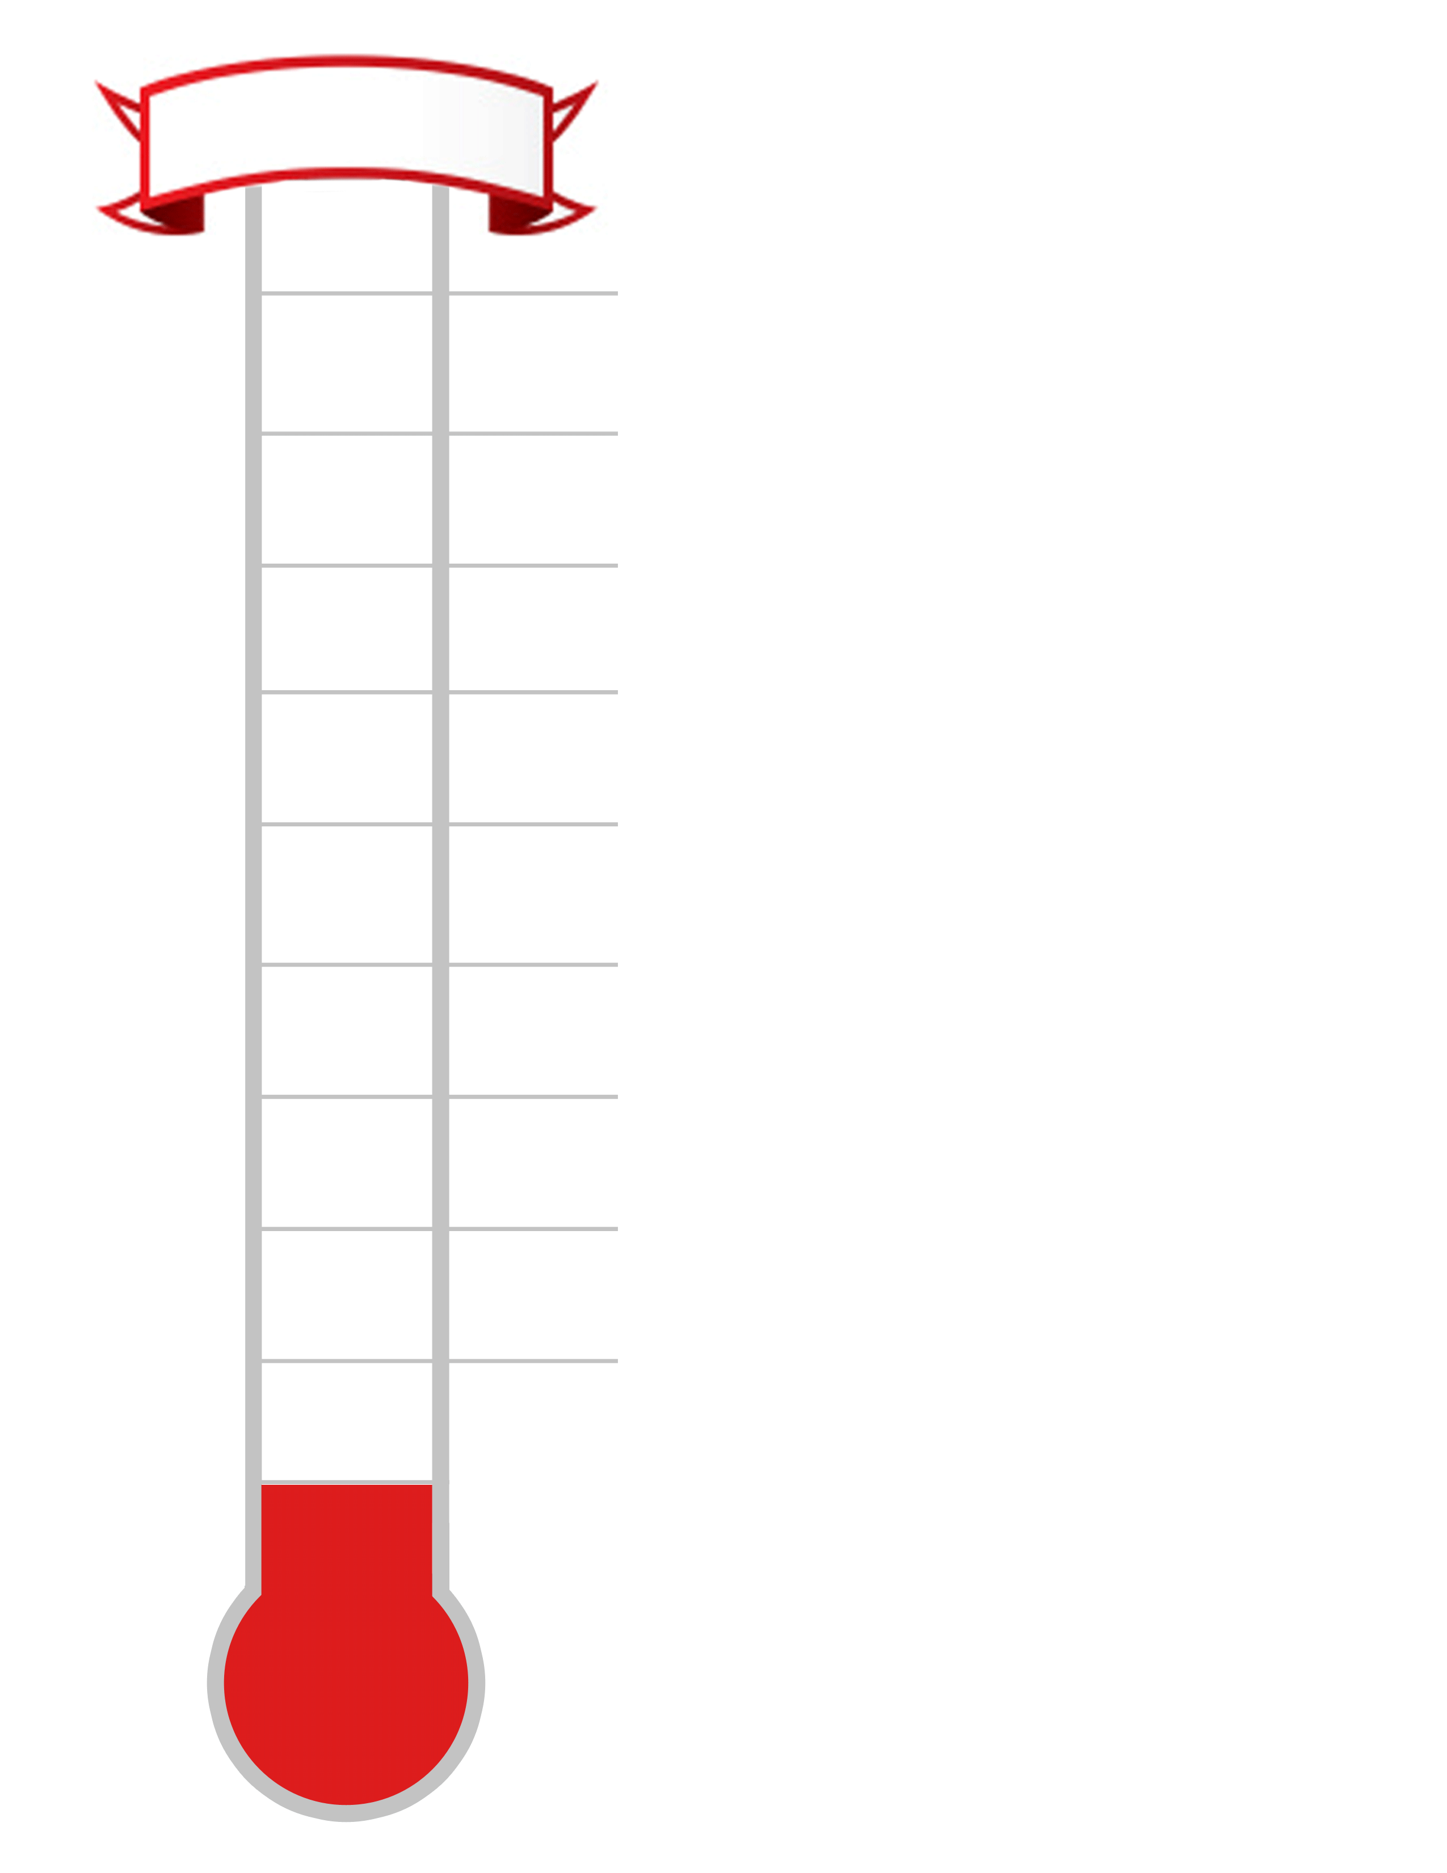
1. Complete the thermometer on the right hand side.
-7ºC
-3ºC
0ºC
9ºC
5ºC

Use your thermometer to help answer the questions
below.

2.
a) What is 3 more than 6ºC? ____________

b) What is 5 less than 7ºC? ____________

c) What is the difference between 8^{O}C and 2ºC?

_____________

d) What is 3 less than 1ºC? ______________

e) What is 9 more than -3ºC? _____________

f) What is 5 less than -2^{O}C? ____________

g) What is the difference between 3^{O}C and -4^{O}C?

_______________

h) What is the difference between -2ºC and -8ºC?

3. The temperatures of 8 world cities are shown below.

Toronto: 7ºC | New York: 9ºC | Harare: 0ºC | Dubai: 13ºC
Auckland: -2ºC | Reykjavik: -7ºC | Tokyo: 4ºC | Helsinki: -3ºC

Use the table and your thermometer to answer the questions below:

a) Which city is the coldest? __________________

b) Which city is 3 degrees colder than Toronto? __________________

c) Which city is 5 degrees warmer than Tokyo? __________________

d) Which city is 13 degrees colder than Dubai? __________________

e) Which city is 2 degrees colder than Harare? __________________

f) Which city is 1 degree warmer than Helsinki? __________________

g) Which city is 7 degrees colder than Tokyo? __________________

h) What is the difference in temperature between Reykjavik and Auckland? ____________

i) What is the difference in temperature between New York and Reykjavik? ____________

4. The table below shows how the temperatures changed 6 months later.

Toronto: fell by 10ºC | New York: fell by 8ºC | Harare: rose by 8ºC | Dubai: fell by 5ºC
Auckland: rose by 9ºC | Reykjavik: fell by 6ºC | Tokyo: fell by 6ºC | Helsinki: rose by 4ºC

Use this information to fill in the table below showing the temperatures in 6 months time.

Toronto: ___ºC | New York: ___ºC | Harare: ___ºC | Dubai: ___ºC
Auckland: ___ºC | Reykjavik: ___ºC | Tokyo: ___ºC | Helsinki: ___ºC

