**English**

This term we will be looking at the work of the incredible Roald Dahl, we are going to read, listen to and share some of his stories. These stories will be the basis for our writing where we will look at writing descriptively, diary writing and re telling stories. Through this work we will feed in our SPaG learning, recapping on word classes, punctuation rules, new spelling strategies and grammar.

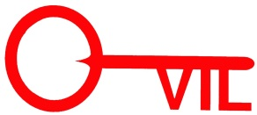

**Keevil CE Aided Primary School**

**Learning in the term ahead**

Class: Spring

[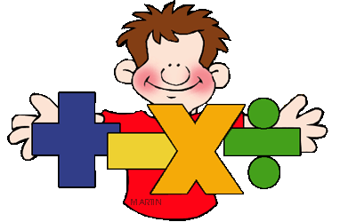](http://www.google.co.uk/url?sa=i&rct=j&q=clipart+maths&source=images&cd=&cad=rja&uact=8&ved=0CAcQjRw&url=http://math.phillipmartin.info/&ei=4_Z2VaiaFciN7AaY9IGwBg&psig=AFQjCNGo5VxK1fCJXBQEo_6NjKx0w56UjQ&ust=1433946187819279)[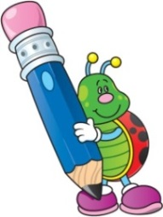](http://www.google.co.uk/url?sa=i&rct=j&q=clipart+writing&source=images&cd=&cad=rja&uact=8&ved=0CAcQjRw&url=http://www.cliparthut.com/writing-folder-clipart.html&ei=dPd2VdDGHILj7Qabg4C4CQ&psig=AFQjCNH0fs5RgKxxjjYWx7Q7pSDbGug4cA&ust=1433946350728263)Term: 1 2018

[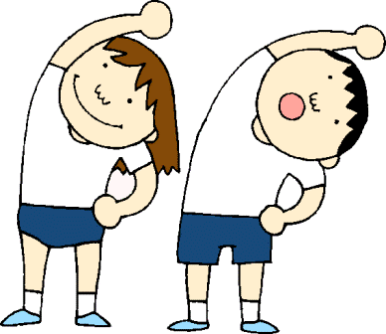](http://www.google.co.uk/url?sa=i&rct=j&q=clipart+pe&source=images&cd=&cad=rja&uact=8&ved=0CAcQjRw&url=http://www.clipartpanda.com/categories/pe-class-clipart&ei=i_l2VdWCNcLB7AbC9YH4CQ&psig=AFQjCNHunG1V_E8HkEKpZlyb39Vtsy2gCA&ust=1433946879166045)[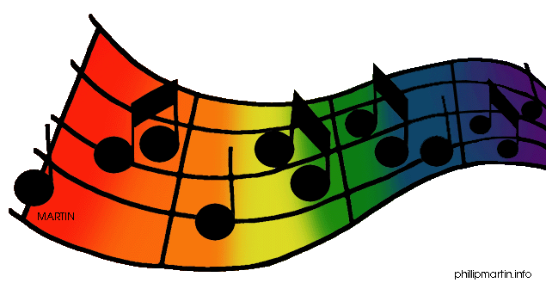](http://www.google.co.uk/url?sa=i&rct=j&q=clipart+music&source=images&cd=&cad=rja&uact=8&ved=0CAcQjRw&url=http://www.clipartpanda.com/categories/clipart-music-notes&ei=0_l2VajADoH67AaDooPYAg&psig=AFQjCNETyjPoJdd0IxJKODwQwHCy81I9rw&ust=1433946955029635)[](http://www.google.co.uk/url?sa=i&rct=j&q=clipart+religion&source=images&cd=&cad=rja&uact=8&ved=0CAcQjRw&url=http://www.canstockphoto.com/religion-icons-5285101.html&ei=wPd2VeivINDT7AaRiYKQBQ&psig=AFQjCNGvETEcdgp3JNG30BR3eRGGsnGDJw&ust=1433946411911815)[](http://www.google.co.uk/url?sa=i&rct=j&q=clipart+geography&source=images&cd=&cad=rja&uact=8&ved=0CAcQjRw&url=http://www.clipartpanda.com/categories/geography-clipart-black-and-white&ei=G_l2Vbr0KILm7ga9g4G4BA&psig=AFQjCNGWbF-50cfXyU3PVpIvmPLoTqpYJA&ust=1433946761437782)[](http://www.google.co.uk/url?sa=i&rct=j&q=clipart+science&source=images&cd=&cad=rja&uact=8&ved=0CAcQjRw&url=http://manshamahtani.com/science-fair-clip-art&ei=TPh2VaP3AoSU7AbDsoCICQ&psig=AFQjCNHoHI3d_L_KUxYR_usObtwTDUPUhQ&ust=1433946549049225)[](http://www.google.co.uk/url?sa=i&rct=j&q=clipart+art&source=images&cd=&cad=rja&uact=8&ved=0CAcQjRw&url=http://www.clipartpanda.com/categories/artist-clip-art&ei=iPh2Vc-YDMmw7Aa60IPoAg&psig=AFQjCNGPQje2q8Wyzpgs_gyMad_4DvjFHQ&ust=1433946622019842)[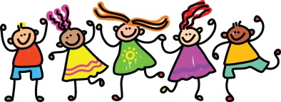](http://www.google.co.uk/url?sa=i&rct=j&q=clipart+friends&source=images&cd=&cad=rja&uact=8&ved=0CAcQjRw&url=http://cliparts.co/clip-art-of-friends&ei=EPp2VbbRMOGs7Ab00oOYBg&psig=AFQjCNEs9KYihyqCQapdwBhANqtbU0KZvQ&ust=1433947009480034)

**Music**

In music this term we will be learning to play the recorder with Mrs Fowler.

**Maths**

This terms maths focus is Place Value. We will begin by counting in steps of different numbers, forward and backwards. We need to be able to read and write numbers in numerals and words to at least 100 whilst learning to recognise the value of each digit in a number. Once we are confident with this we will look to compare and order numbers using the <, >, = signs and be able to confidently verbalise what this means. Towards the end of the term we will begin to recall our addition and subtraction facts fluently and learn to apply these to other related facts.

**RE**

We will be starting the year looking at Christianity where we will consider what Christians believe God is like. We will think about hidden meanings in different parables from the bible as well

as think of God’s qualities as similar to

those of parents.

**Geography**

In Geography this term we will be looking at our local area. We will explore Keevil by taking a look around the village, exploring photos and talking about the human and physical features our village has. We will explore maps and understand more about where we live on a map of the UK including the county we live in.

**Science**

Our Science work this term is based on magnets and forces. We will learn about forces in the context of pushing and pulling. We will work to investigate friction and conduct some experiments to find out new information. We will work hands on to identify different magnetic materials

as well as the strength of different types of magnets.

**DT**

This term in DT we will be evaluating, designing and making our own playgrounds. This fits in with our exciting changes at school. We will explore existing playgrounds thinking about what equipment we do and don’t like. We will plan our own playground before making our own

mini playground.

**PE**

In PE we will be working with our external PE teachers on a variety of co-ordination and skills based games whilst developing our team work skills.

**PSHE**

We will be doing our PSHE work through a ‘Wellbeing Day’ later in

the term, which will be

focused on relationships

with our peers.