1
a an
as at the
2
if in
is it to
3
of off
on can
4
dad had
back
and no
5
get big
him his not
go

6
got into
up mum but
put
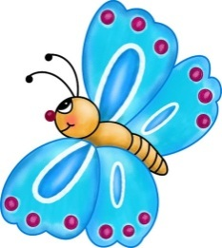
7
will that
this she we
he
8
then them
with me
be was
9
see for
now you they
all
10
down look
too are my her

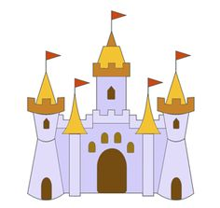
11
went it’s
said so
have like
12
do from
children
some come were there

13
one out
help just
little
when what

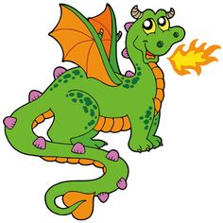
14
don't
old I’m
oh their
15
by Mr
people
house
about time
16
your day Mrs
made
looked
called came
17
saw very
asked here
could make
18
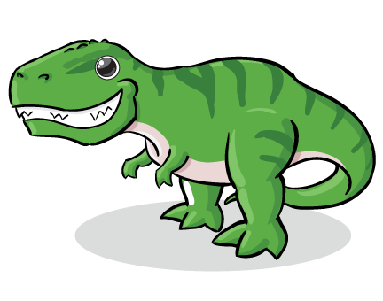
water away good want
going did
over how
man where
19
would or took
school
home who didn’t think
ran know

20
bear can’t again
long cat
things new eat
after wanted

21
our two thought
everyone has
yes play
dog well take
22
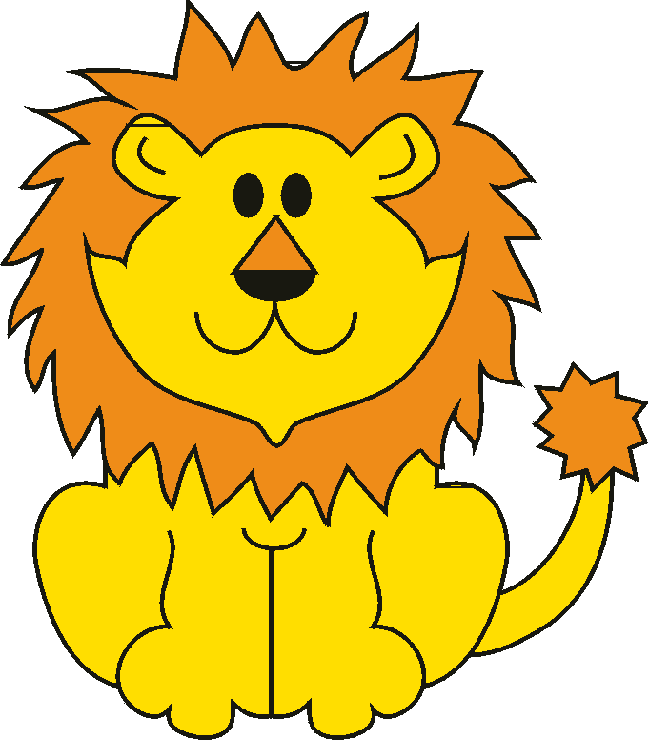
find more round
tree magic
shouted I’ll
us other food
23
fox through way
been stop
must red
right sea door
24
these began boy
animals never
next first work
lots need
25
that's baby fish
gave mouse
may still found
something bed

26
night narrator couldn’t
three head
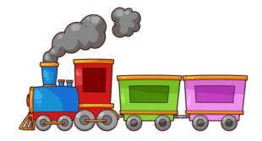
live say soon
small car
27
garden laughed around
every many
king I’ve town
fast only
28
suddenly another great
much cried
let’s told why
keep room
29
jumped because clothes
before even
last am gran
tell key
30
fun place mother
window morning
sat boat sleep
feet queen

31
each book its
green different
let girl which
inside run
32
any under hat
snow air
trees bad tea
top eyes
33
fell friends box
grandad there’s
dark end than
looking best
34
better floppy really
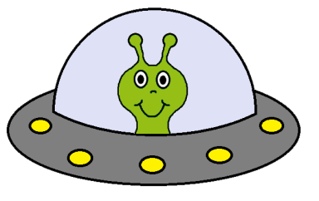
across gone
hot sun wish
hard wind
35
please stopped thing
eggs once
ever miss most
cold park

36
horse rabbit white
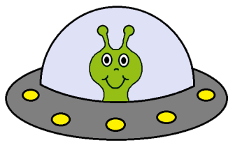
lived duck
birds he’s river
coming liked
37
giant plants dragon
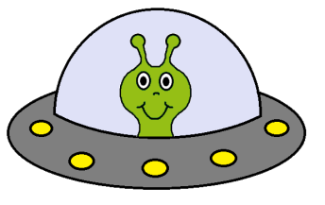
pulled looks
use along fly
we’re grow

