**English**

This term we will be reading Phillip Pullman’s ‘Clockwork’ analyzing the authors style of writing and the effect of language within the story. We will be continuing to look at sentence structure through Spelling Punctuation And Grammar (SPAG) lessons and this term we will be working on our understanding and application of word classes (nouns, adjectives, adverbs, pronouns and prepositions) and how these can be used in our writing.



[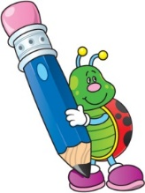](http://www.google.co.uk/url?sa=i&rct=j&q=clipart+writing&source=images&cd=&cad=rja&uact=8&ved=0CAcQjRw&url=http://www.cliparthut.com/writing-folder-clipart.html&ei=dPd2VdDGHILj7Qabg4C4CQ&psig=AFQjCNH0fs5RgKxxjjYWx7Q7pSDbGug4cA&ust=1433946350728263)**Keevil CE Aided Primary School**

**Learning in the term ahead**

**Class: Autumn Term: 1**

[](http://www.google.co.uk/url?sa=i&rct=j&q=clipart+computer&source=images&cd=&cad=rja&uact=8&ved=0CAcQjRw&url=http://www.clipartpanda.com/categories/kids-art-class-clip-art&ei=Bvh2Vau4FqTg7QaTgoHQBw&psig=AFQjCNGMIdQ6tV01DJDDgd3KLhh8fcT_JA&ust=1433946483855768)[](http://www.google.co.uk/url?sa=i&rct=j&q=clipart+religion&source=images&cd=&cad=rja&uact=8&ved=0CAcQjRw&url=http://www.canstockphoto.com/religion-icons-5285101.html&ei=wPd2VeivINDT7AaRiYKQBQ&psig=AFQjCNGvETEcdgp3JNG30BR3eRGGsnGDJw&ust=1433946411911815)[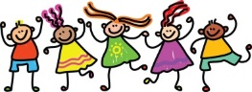](http://www.google.co.uk/url?sa=i&rct=j&q=clipart+friends&source=images&cd=&cad=rja&uact=8&ved=0CAcQjRw&url=http://cliparts.co/clip-art-of-friends&ei=EPp2VbbRMOGs7Ab00oOYBg&psig=AFQjCNEs9KYihyqCQapdwBhANqtbU0KZvQ&ust=1433947009480034)[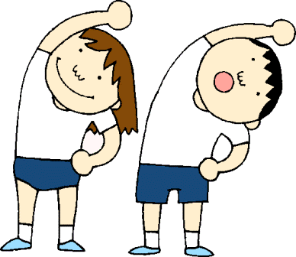](http://www.google.co.uk/url?sa=i&rct=j&q=clipart+pe&source=images&cd=&cad=rja&uact=8&ved=0CAcQjRw&url=http://www.clipartpanda.com/categories/pe-class-clipart&ei=i_l2VdWCNcLB7AbC9YH4CQ&psig=AFQjCNHunG1V_E8HkEKpZlyb39Vtsy2gCA&ust=1433946879166045)[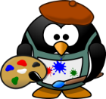](http://www.google.co.uk/url?sa=i&rct=j&q=clipart+art&source=images&cd=&cad=rja&uact=8&ved=0CAcQjRw&url=http://www.clipartpanda.com/categories/artist-clip-art&ei=iPh2Vc-YDMmw7Aa60IPoAg&psig=AFQjCNGPQje2q8Wyzpgs_gyMad_4DvjFHQ&ust=1433946622019842)[](http://www.google.co.uk/url?sa=i&rct=j&q=clipart+geography&source=images&cd=&cad=rja&uact=8&ved=0CAcQjRw&url=http://www.clipartpanda.com/categories/geography-clipart-black-and-white&ei=G_l2Vbr0KILm7ga9g4G4BA&psig=AFQjCNGWbF-50cfXyU3PVpIvmPLoTqpYJA&ust=1433946761437782)[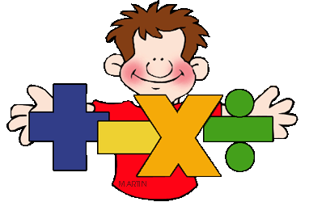](http://www.google.co.uk/url?sa=i&rct=j&q=clipart+maths&source=images&cd=&cad=rja&uact=8&ved=0CAcQjRw&url=http://math.phillipmartin.info/&ei=4_Z2VaiaFciN7AaY9IGwBg&psig=AFQjCNGo5VxK1fCJXBQEo_6NjKx0w56UjQ&ust=1433946187819279)[](http://www.google.co.uk/url?sa=i&rct=j&q=clipart+science&source=images&cd=&cad=rja&uact=8&ved=0CAcQjRw&url=http://manshamahtani.com/science-fair-clip-art&ei=TPh2VaP3AoSU7AbDsoCICQ&psig=AFQjCNHoHI3d_L_KUxYR_usObtwTDUPUhQ&ust=1433946549049225)

**RE**

This term our RE lessons will be based on the key question: ‘What does it mean if God is holy and loving?’ They will be discussing and sharing their beliefs on God, whilst also showing compassion and understanding of others and their beliefs.

**Computing**

This term we will be focusing on E-Safety and our general ICT skills. Demonstrating how to use technology safely and responsibly as well as learning how to use a range of programmes effectively.

**Art**

The children conducting an artist study of Henri Rousseau. Analyzing his style of art and improving their mastery of art and design techniques, including drawing, painting and sculpture with a range of materials.

**PSHE**

Our PSHE day this term will be based on the theme of ‘Friendship’, looking at different areas of friendships such as how our actions can affect ourselves and others.

**PE**

Acorn PE will be taking our lessons this term. The children will be playing a variety of different sports and working on a range of new and existing skills.

**Geography**

In Geography we will be studying a region from South America. The children will be identifying various countries, using maps to focus on South America. Learning about their environmental regions, key physical and human characteristics, the different countries and major cities.

**Science**

Our topic for Science this term is ‘Forces and Friction’ . We will be learning about gravity

and why unsupported objects fall to the ground. We will be learning about the effects of air resistance and water resistance. We will also be learning to recognize some mechanisms such as levers gears and pulleys.

**Maths**

Our focus for Maths this term will be on place value. We will be developing our understanding of larger numbers. The children will be comparing and ordering numbers, recognizing the value of the different digits within larger numbers. The children will also be learning about powers of ten and counting forwards and backwards from a given number.