

**Communication, Language and Literacy**

In phonics Reception are using all the sounds we know to read and spell longer words with trickier spelling combinations like ‘s-c-r-ee-n’

Year 1 are consolidating all their alternative phase 5 sounds. In English we are looking at books with the theme of Transport .

**[](http://www.google.co.uk/url?sa=i&rct=j&q=clipart+writing&source=images&cd=&cad=rja&uact=8&ved=0CAcQjRw&url=http://www.cliparthut.com/writing-folder-clipart.html&ei=dPd2VdDGHILj7Qabg4C4CQ&psig=AFQjCNH0fs5RgKxxjjYWx7Q7pSDbGug4cA&ust=1433946350728263)Learning in the term ahead:**

**Transport**

**Class: Winter Term: 6**

**Mathematics**

In Math’s Reception are consolidating their number bond fact and securing their number knowledge as well as counting beyond 20. Year 1 are getting to grips with sharing and making groups as we tackle multiplication and division.

We will also all be

looking at time

and Money.

**Religious Education**

In R.E we will all be learning about the Jewish

faith and finding out more about the meal of Shabbat. We will find out why it is important and how it is celebrated.

[](http://www.google.co.uk/url?sa=i&rct=j&q=clipart+religion&source=images&cd=&cad=rja&uact=8&ved=0CAcQjRw&url=http://www.canstockphoto.com/religion-icons-5285101.html&ei=wPd2VeivINDT7AaRiYKQBQ&psig=AFQjCNGvETEcdgp3JNG30BR3eRGGsnGDJw&ust=1433946411911815)

[](http://www.google.co.uk/url?sa=i&rct=j&q=clipart+maths&source=images&cd=&cad=rja&uact=8&ved=0CAcQjRw&url=http://math.phillipmartin.info/&ei=4_Z2VaiaFciN7AaY9IGwBg&psig=AFQjCNGo5VxK1fCJXBQEo_6NjKx0w56UjQ&ust=1433946187819279)

**Expressive Arts and Design**

In DT year 1 will be looking at making moving cars using axels and Reception will also be making and drawing different type of transport in construction areas and the craft corner.

**Understanding of the World**

In Science Year 1 will start to think about electricity, what it does and how to be safe around it.

Reception will also learn how to be safe and we will all continue to find bugs and enjoy the sign of summer all around us.

[](http://www.google.co.uk/url?sa=i&rct=j&q=clipart+geography&source=images&cd=&cad=rja&uact=8&ved=0CAcQjRw&url=http://www.clipartpanda.com/categories/geography-clipart-black-and-white&ei=G_l2Vbr0KILm7ga9g4G4BA&psig=AFQjCNGWbF-50cfXyU3PVpIvmPLoTqpYJA&ust=1433946761437782)

[](http://www.google.co.uk/url?sa=i&rct=j&q=clipart+art&source=images&cd=&cad=rja&uact=8&ved=0CAcQjRw&url=http://www.clipartpanda.com/categories/artist-clip-art&ei=iPh2Vc-YDMmw7Aa60IPoAg&psig=AFQjCNGPQje2q8Wyzpgs_gyMad_4DvjFHQ&ust=1433946622019842)

[](http://www.google.co.uk/url?sa=i&rct=j&q=clipart+music&source=images&cd=&cad=rja&uact=8&ved=0CAcQjRw&url=http://www.clipartpanda.com/categories/clipart-music-notes&ei=0_l2VajADoH67AaDooPYAg&psig=AFQjCNETyjPoJdd0IxJKODwQwHCy81I9rw&ust=1433946955029635)

**Personal, Social and Emotional Development**

In spirituality we are talking about the whole world and how amazing it is so that we can appreciate the need to look after it! As we get ready to move into

Spring class we will be taking part in transition mornings to help us prepare.

**Physical Development**

Our weekly P.E. Sessions will continue and on a Friday afternoon we will all go swimming – the class are very excited! We will also be using sewing boards and pattern games to

develop or fine motor skills which

makes our handwriting lovely!

[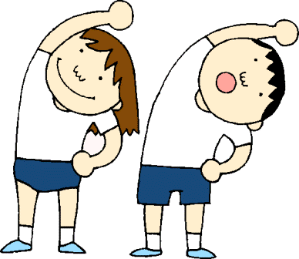](http://www.google.co.uk/url?sa=i&rct=j&q=clipart+pe&source=images&cd=&cad=rja&uact=8&ved=0CAcQjRw&url=http://www.clipartpanda.com/categories/pe-class-clipart&ei=i_l2VdWCNcLB7AbC9YH4CQ&psig=AFQjCNHunG1V_E8HkEKpZlyb39Vtsy2gCA&ust=1433946879166045)

[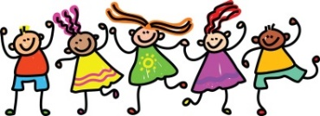](http://www.google.co.uk/url?sa=i&rct=j&q=clipart+friends&source=images&cd=&cad=rja&uact=8&ved=0CAcQjRw&url=http://cliparts.co/clip-art-of-friends&ei=EPp2VbbRMOGs7Ab00oOYBg&psig=AFQjCNEs9KYihyqCQapdwBhANqtbU0KZvQ&ust=1433947009480034)



**Learning at home to support work in school**

Please continue to read at home and practice your number bond facts using the app! See if you can spot wheels on things and talk about how the wheels move and look out for any books with transport in – maybe you have a story about a train!