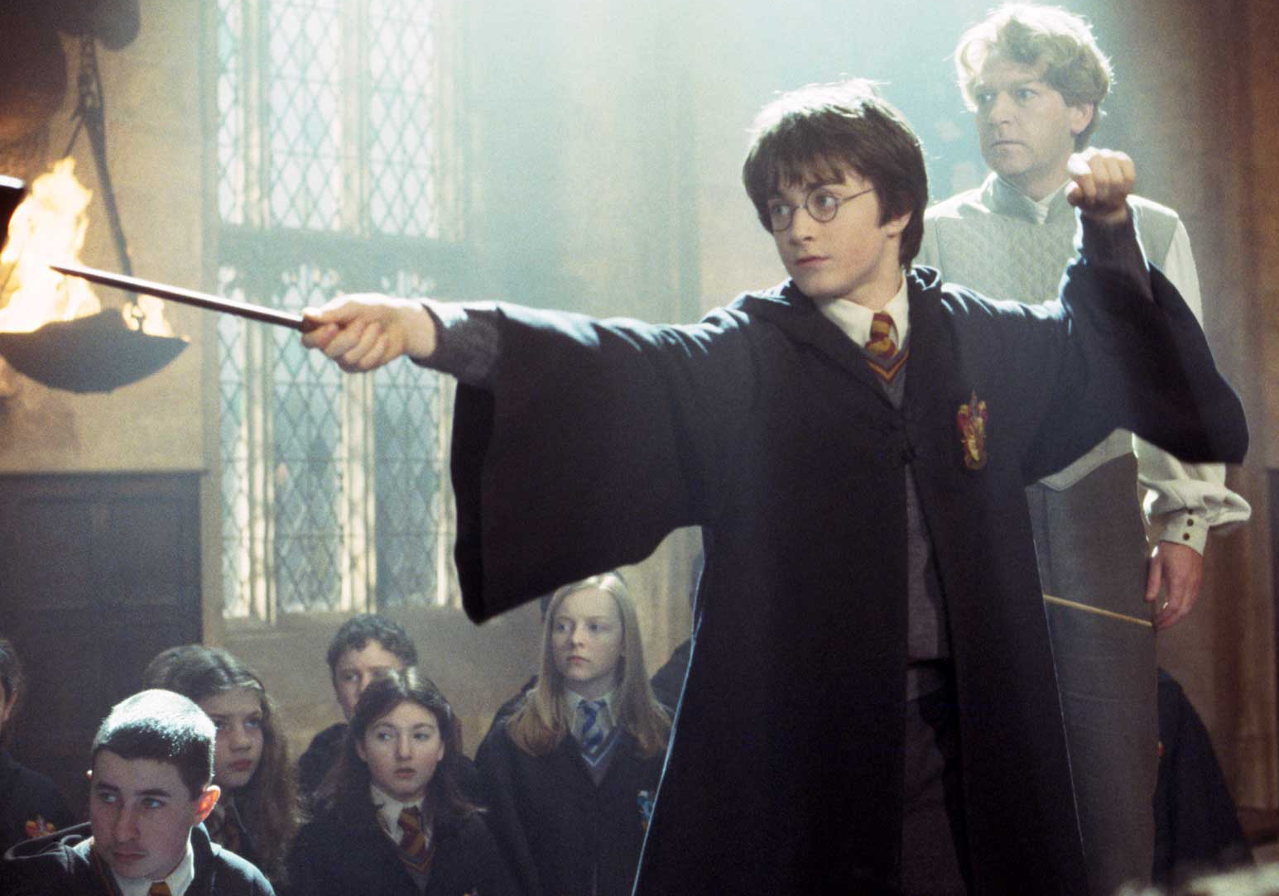
English Work

Knowing what you know about Harry and each of the houses, what do you think would have become of Harry had the Sorting Hat placed him in Slytherin as it had originally considered?

