Keevil Church of England Academy

Art & Design Technology Subject Report

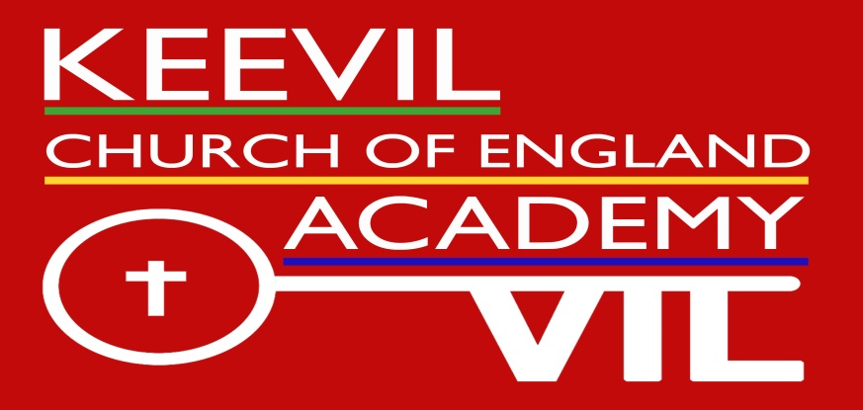

**Emma Mortimer**

**Spring 2018**

Resilience Diligence Teamwork Communication Learning Problem solving

National Curriculum: Purpose of study

Art, craft and design represent some of the greatest forms of human creativity. A high-quality art and design education should engage, inspire and challenge pupils, equipping them with the knowledge and skills to experiment, invent and create their own works of art, craft and design. As pupils progress, they should be able to think critically and develop a more rigorous understanding of art and design. They should also know how art and design both reflect and shape our history, and contribute to the culture, creativity and wealth of our nation.

**What our children say about Art/Design**

* “Let’s out your imagination and inner self.” (Year 3)
* “It doesn’t matter if you’re not good at art because the only thing that matters is that you have fun and enjoy it.” (Year 4)
* “Unlike writing which gets trapped in school with the teachers, you can take Art/Design work home to share with your family.” (Year 4)
* “We get to use new things like Blue Tac and Selotape.” (Reception)
* “We get to share things we’ve done in Worship.” (Year 2)
* “Art makes me happy.” (Year 1)
* “In Design Technology you get to try foods you and your friends have made.” (Year 3)
* “Art is relaxing and peaceful.” (Year 5)
* “I like the subjects because there is no wrong or right and you can make it your own.” (Year 6)
* “When you use new materials you’re able to get a taste for new things.” (Year 5)

**National Curriculum Art and Design aims:**

The national curriculum for art and design aims to ensure that all pupils:

* produce creative work, exploring their ideas and recording their experiences
* become proficient in drawing, painting, sculpture and other art, craft and design techniques
* evaluate and analyse creative works using the language of art, craft and design
* know about great artists, craft makers and designers, and understand the historical and cultural development of their art forms.

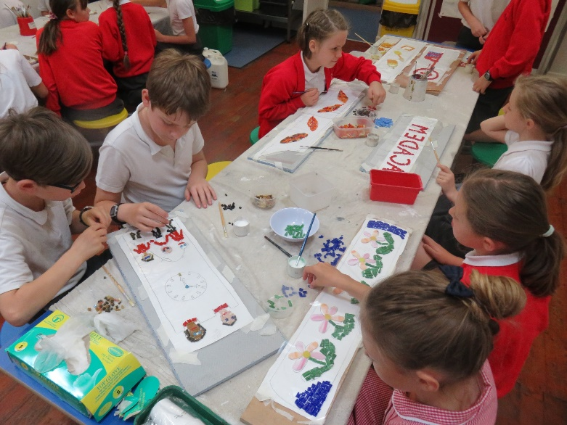**Keevil School Art and Design aims:**

* To stimulate imagination, creativity and thinking.
* To recognise and nurture the importance of creativity within our pupils.
* To develop an understanding of diverse art forms from both within and beyond the children’s learning environment.
* To provide our children with opportunities to develop and express ideas through the making and presenting of artworks.
* To enable children to become critically aware of, and respond to, their own work and other’s work.
* To acknowledge and appreciate a range of artists, craft makers and designers.
* To develop the skills of enquiry, investigation, analysis, evaluation and problem solving.

Teaching Art and Design

The teaching of Art and Design Technology (DT) at Keevil changes through the school according to the individual class’ age. Art is planned on a two year cycle. In EYFS and KS1 art skills are taught in themes which coincide with the main topics for the year, e.g. mini beasts, travel, country focuses. Whereas in KS2 art is taught as a stand-alone unit several times a year as it alternates with Design Technology, e,g. colour mixing, Kandinsky and Klee, printing, observational drawing.

Similarly, Design Technology (DT) is planned on a two year cycle where it is incorporated into the main topic teaching for EYFS and KS1. In KS2 DT alternates with Art as a stand-alone subject which includes the teaching of designing, making and evaluating products using a wide range of equipment, tools and materials. It also includes teaching about where food comes from and the basic principles of a healthy diet.

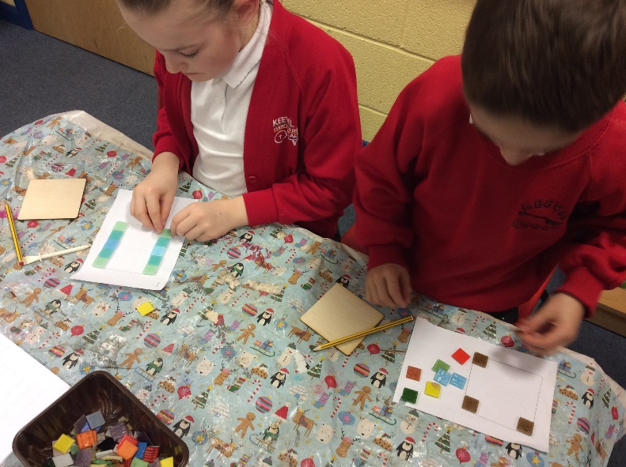Due to the nature of the subjects, the prominent approach to learning in these subjects at Keevil is through a practical, hands on culture which allows the children to explore their imagination as creatively as possible. The practical nature of the sessions allows the children to learn to manipulate tools and equipment to accomplish a given outcome and explore a range of textures. Additional enrichment, such as themed visits and visitors are carried out to further the awareness, thinking and importance of creativity amongst the pupils. We also provide whole school projects for the children to contribute to which gives all children a sense of belonging and collaboration. Whole school projects include the Keevil Academy mosaic that all children contributed to and is displayed for all to see in the school playground.

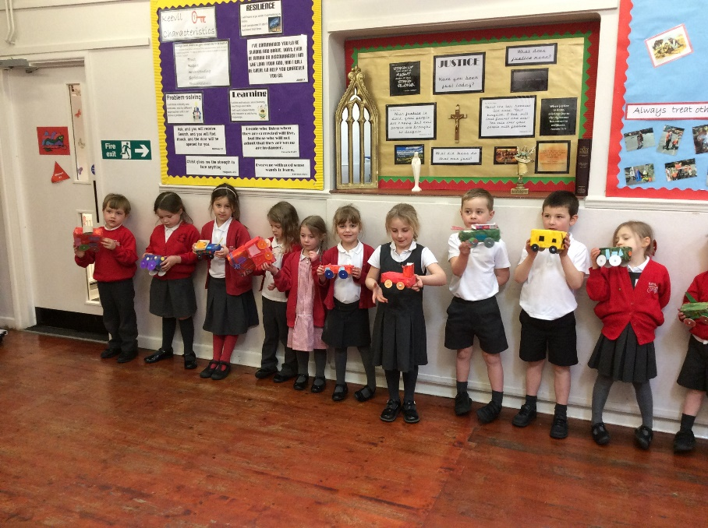Some Art/Design topics have been enhanced by educational visits and enrichment opportunities:-

* Remembrance activities in November are a very meaningful context for learning.
* Winter & Spring Class trips to Bristol Aerospace museum to support their DT learning of transport.
* Summer class Roman visitor.
* Spring class Pirate visitor.
* Autumn Class residential to Pencelli.
* Summer Class trip to Pizza Express

Curriculum Planning and Evaluation Systems

The National Curriculum programmes of study guide the planning, teaching and assessment of pupil’s work. The programmes of study for each Key Stage should be taught to pupils in ways appropriate to their abilities. For some pupils at Keevil School, teachers may have to select skills from an earlier Key Stage to enable pupils to progress and demonstrate achievement.

Art and Design Technology curriculum planning is largely based on requirements of the National Curriculum. Each individual unit has been adapted to make it appropriate to the needs of our children. Long-term plans identify the topics to be taught in each term across the school. Our medium-term plans give further details of each unit of work for each term. The Art/Design Technology subject leader will review these plans on a regular basis. Each class has their own topics to avoid repetition when the children move year groups.

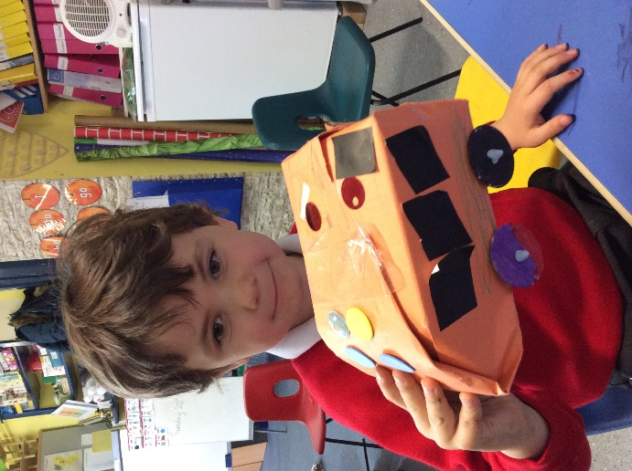Art and Design lessons alternate with one another for each class. During every academic year each class will do a selection of Art units and a selection of Design Technology units. Often, these will run on alternate terms to allow for a varied and exciting curriculum for the children. Units of work are most often delivered by class teachers on a weekly basis however, some skills/themes/units of work lend themselves better to a series of focused days as opposed to weekly sessions and teachers have the freedom to decide on what suits their class best. The 2-yearly topic cycle of objectives ensures that we are covering all objectives over that time, and has led to stronger, more comprehensive planning.

Plans for each unit of work, however they are chosen to be delivered, are produced by the class teachers at the start of each term which are submitted to the Head teacher and stored digitally, alongside evaluations for each lesson taught. The plans list specific learning objectives for each subject, resources needed, clear differentiation and knowledge of where each child is ‘at’ as well as specific adult supported groups. The class teacher keeps these individual plans and can discuss them with the Art/Design Technology subject leader on an informal basis.

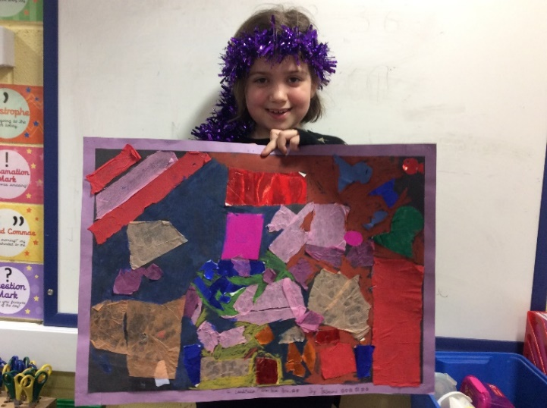

Work scrutiny of pupils’ books and displays reveals that teachers are confident in their differentiation of activities. Cross curricular links are wide and creative. Teachers have stated that in a few cases a lack of adult support and time restraints have restricted the teaching of the subject.

There is currently an ‘Art Club’ being run for KS1 children that is led by KS2 children on a weekly lunchtime basis, overseen by E Mortimer.

Scheme of Work for Art and Design Technology

Foundation Stage: Art and Design are taught through ‘Expressive art and design’, one of the Early Learning Goals (ELGs), which underpin the curriculum planning for children aged three to five. Topics are based on the ‘being imaginative’ and ‘exploring and using medias and materials’ and are planned on a two year rolling program.

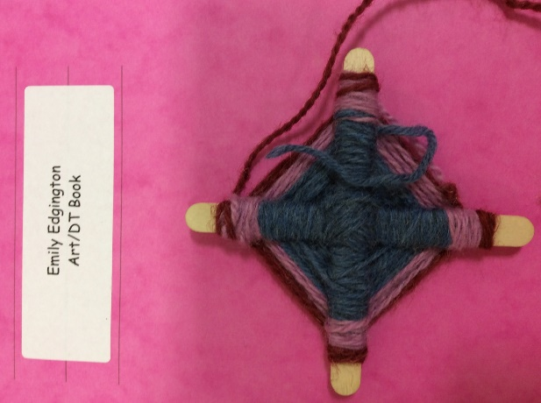

KS1: Art is taught through observational drawing and painting before looking at art from around the world and abstract art. 3D units of work include printing, weaving, collaging and clay models. These year groups are continuing to develop their basic skills in the subjects as well as being exposed to new materials and equipment. The investigation into famous artists is interwoven into the topics.

Design Technology bases itself completely around the topic being taught in class with units such as: Castles- attack and equipment, Space- rockets and planets, Transport- wheeled vehicles. The children also work on a healthy eating unit to further their understanding and skills in this area. KS1 access this through fruit salad and vegetable soup units.

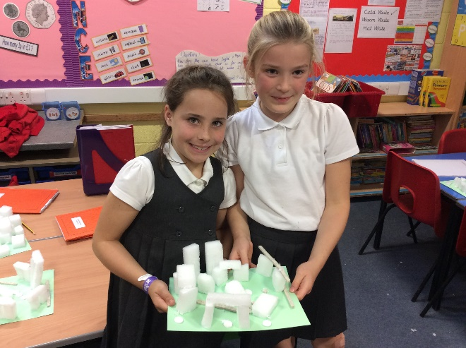

Year 3/4: In years 3/4 there are a range of Art units taught such as drawing skills, weaving, masks and clay plaques. Where possible these units are interwoven into other areas of the curriculum. For example, weaving can be incorporated with looking at the way of life of prior ancestors in history and masks linking to particular times in the Christian calendar such as Mardi Gras. Design Technology units include: torches, horticulture and pizza making. The units are planned with consideration to other foundation subject units of works such as electricity being taught alongside torches, this allows the children to see the link between their subjects and combine the learning they are doing.

Years 5/6: The 2 year rolling program allows for one year to be heavily based on Art and the other Design Technology. This allows the children to develop their skills on a more continuous time frame. Design Technology units include designing and making puppets, moving cards, bread making, weaving and textiles, biscuits and moving vehicles. Whereas Art units incorporate artists studies such as Henri Rousseau and observational drawing.

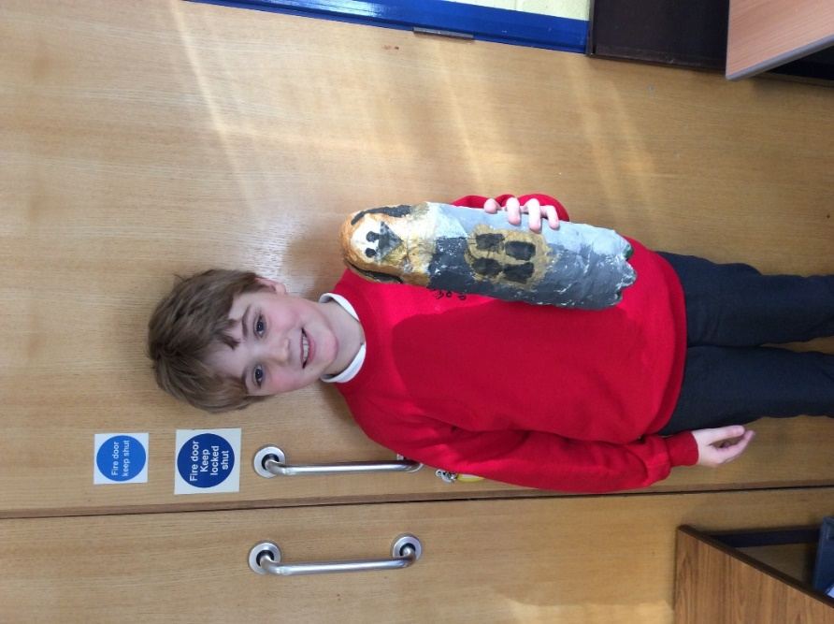Assessment

Assessment is on a continuous monitoring basis involving informal techniques such as teacher observation, small group discussions and questioning about tasks. On completion of a piece of work, the teacher marks the work in accordance with the marking policy and an evaluation recording sheet is completed after each lesson. This is submitted termly to the SLT and stored digitally on the server.

Children’s levels have begun to be recorded on a whole school basis for each unit of work taught. Teachers assess children against skills and objectives set out in the National Curriculum on a tracker. The children’s understanding is assessed to be Exploring, Achieving or Exceeding for each unit taught. Additional needs are also identified for those children who need differentiation that is additional to or different from. Through using this system any low achievers can be identified and supported whilst more able children can be challenged further.

Resources

Keevil is well resourced for Art and DT units and the teachers are expected to order the resources they need in advance for their units. Each class has their own resource bank which is able to be shared freely with other classes. Resources that are specific to individual topics are kept in the appropriate classroom but can be accessed by all. Supporting resources are available to be ordered regularly from Wiltshire Learning Resources, a local resources library, to ensure topics are appropriately resourced.

Resources include:

* Books for staff reference
* Children’s books
* Paper
* Card
* Glue
* Pictures and photographs
* Clay
* Food preparation equipment
* Food
* Paintbrushes/pots
* Moving mechanisms
* Glitter
* Pipe cleaners

Entitlement

Every effort is made to ensure that activities are equally interesting to boys and girls and reflect our multicultural society. Activities are adapted sufficiently that children of all abilities and physical need, can work to their potential.

Staff Development

We believe that staff should possess the subject knowledge required by the National Curriculum and should be able to teach their topics with enthusiasm, confidence and enjoyment. We support staff development in this curriculum area through the attendance of courses and sharing of ideas. Staff share ideas and collaborate with one another on what has worked previously when the teachers move around.

Monitoring and review

The Art/Design subject leader is responsible for monitoring the effectiveness of the teaching and learning in Art and Design across the school. Findings are discussed at an annual review, along with next steps within the subject to improve. Any decisions are made jointly with the rest of the teaching staff at the school. The subject leader will give the Head teacher an annual action plan which outlines the key areas for further improvement.

Art/Design review written by: Emma Mortimer May 2018

Approved by:

Reviewed: